Terraform -05

1). Watch the Terraform-05 video.
Watched

2). Execute the script shown in the video.
Lets create a S3 bucket using terraform script
Need to remember one thing her the bucket name we are giving should be unique
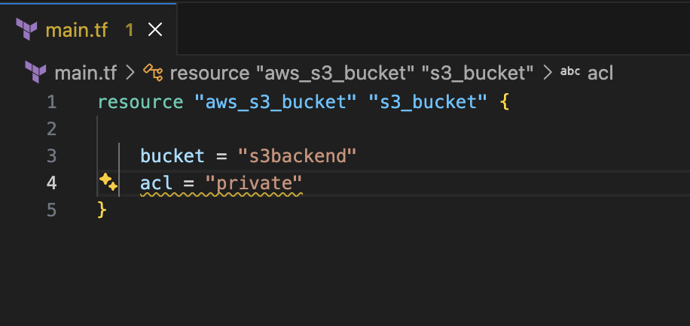
First terraform init
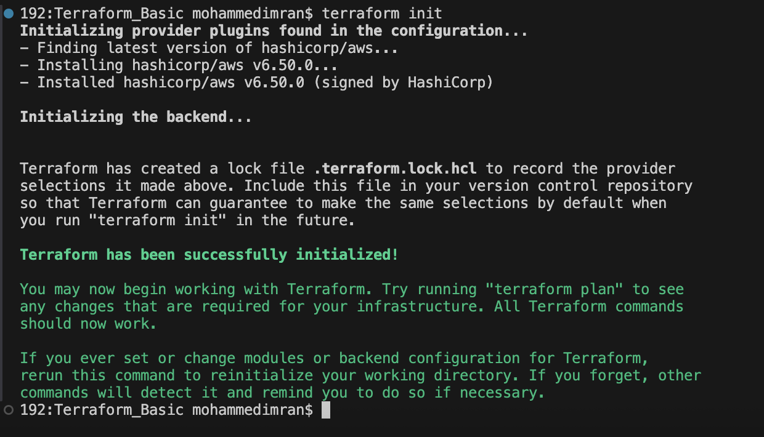
Now terraform apply
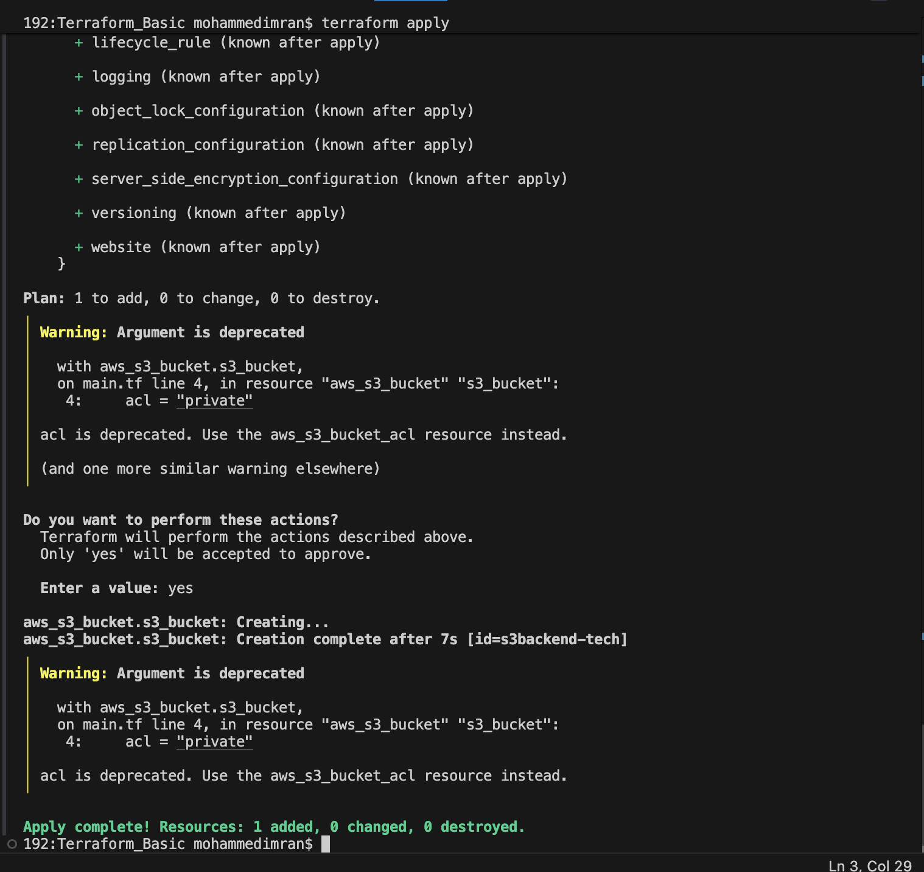
It says a bucket has been created. Lets check in AWS S3
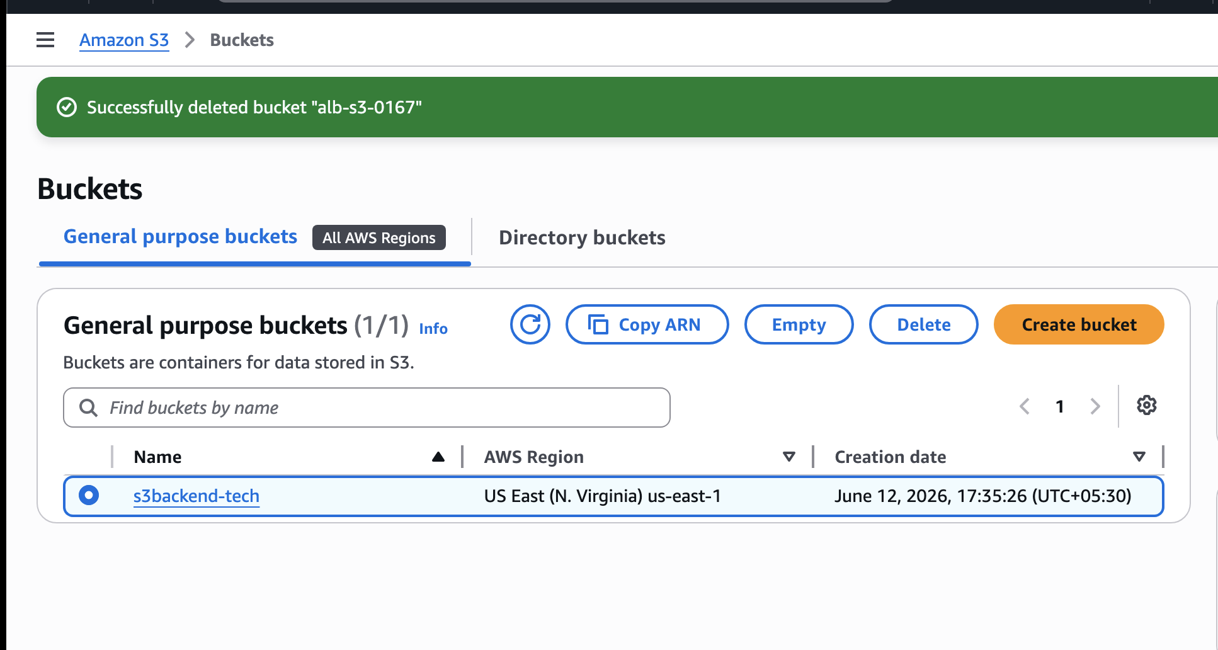
Lets Create Dynamo db using terraform script in the same main.tf file
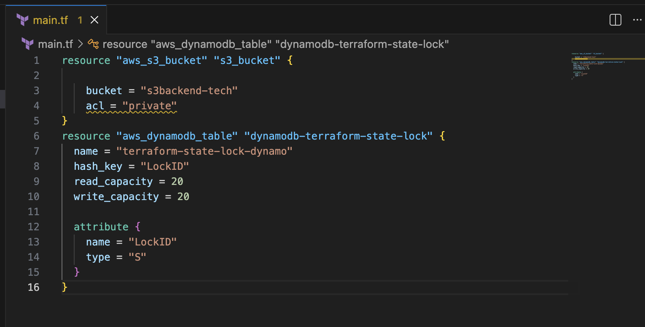
Lets do terraform apply
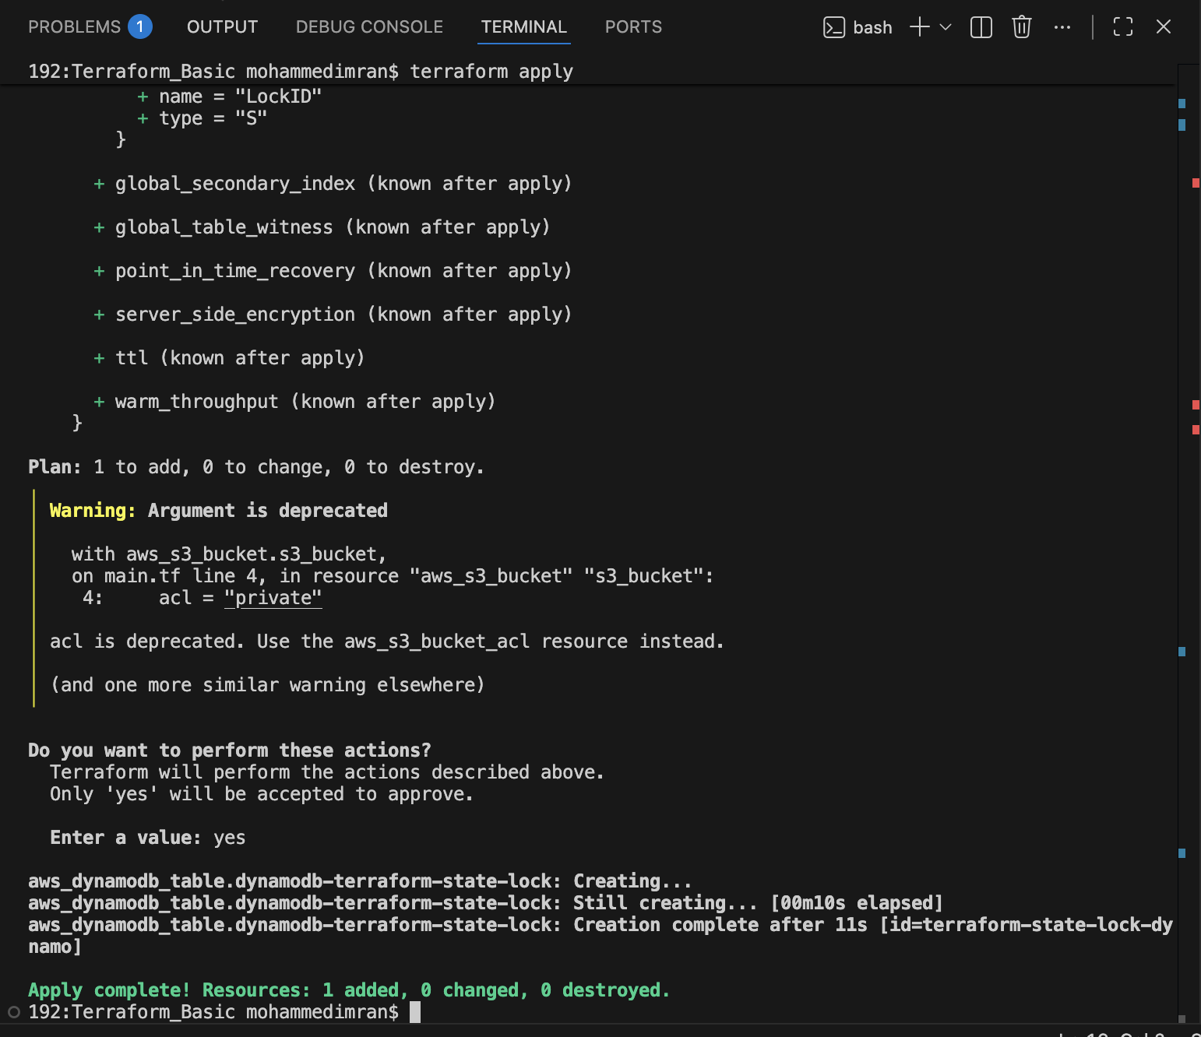
Lets check in AWS Dynamo db
dynamo db table has been created
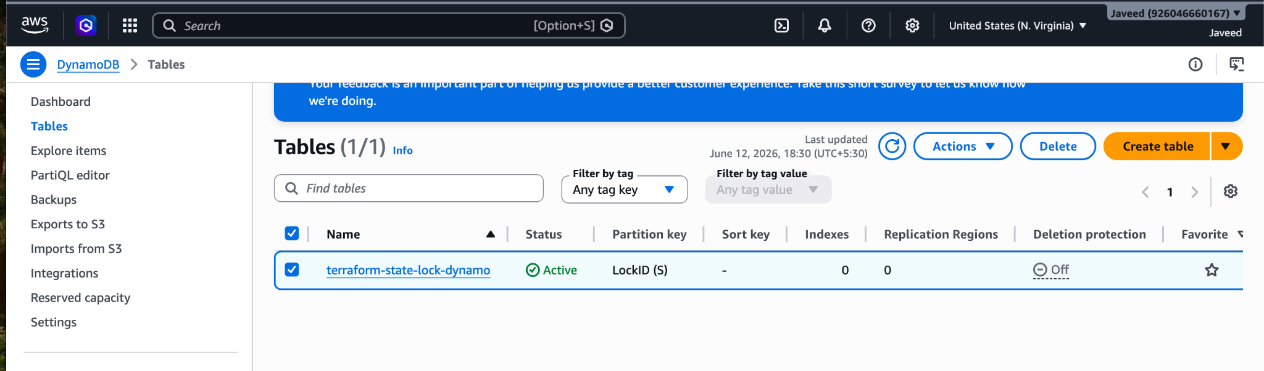

S3 as backend for terraform.tfstate file:
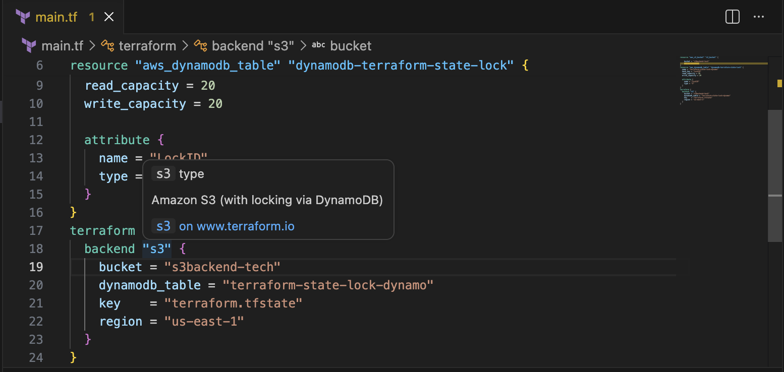
Lets execute terraform apply
It will be throwing an error and will ask us to do intialize

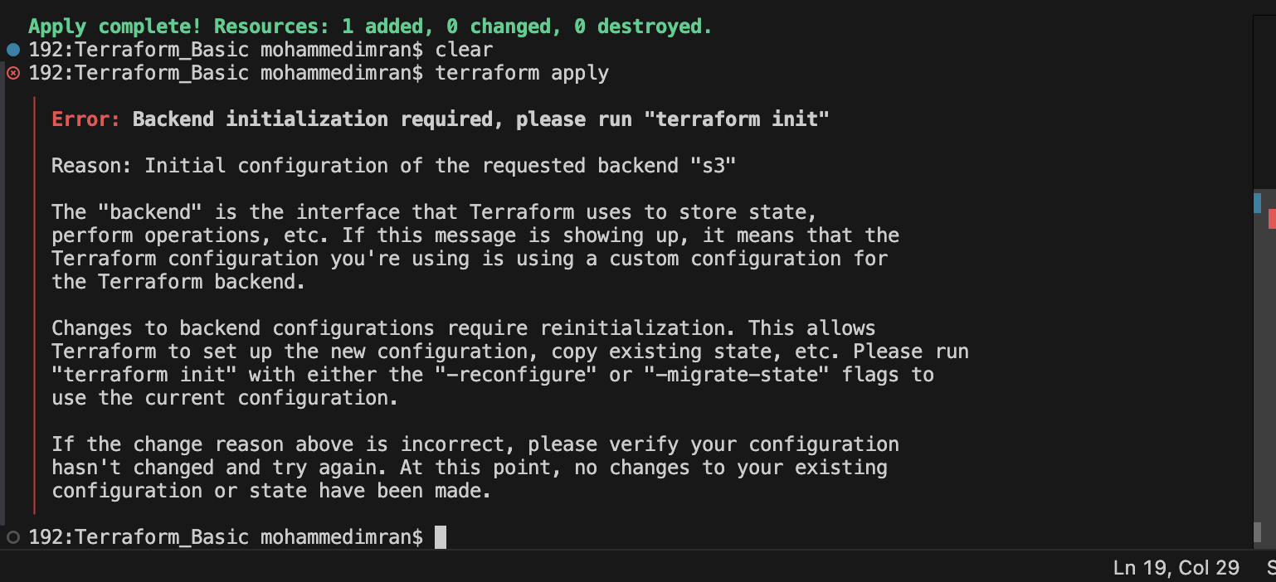
Lets see what happens when we do terraform init
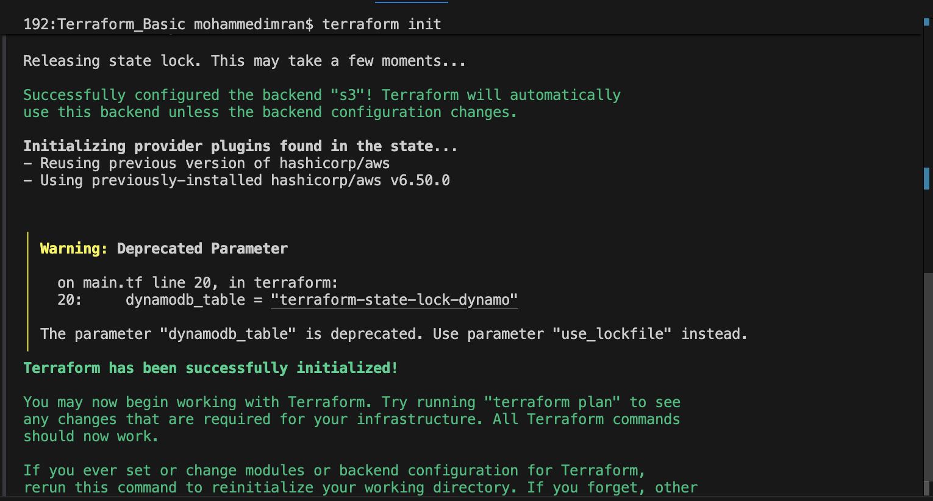

Lets see what happened to terraform.tfstate file
After executing the terraform init all the details in my statefile have been deleted
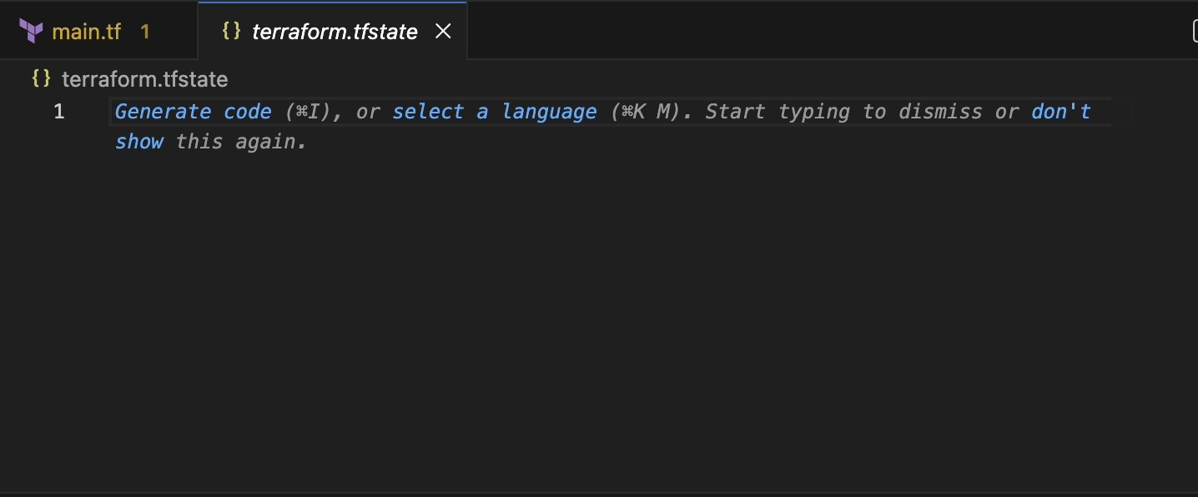
Lets check how previously my statefile looked

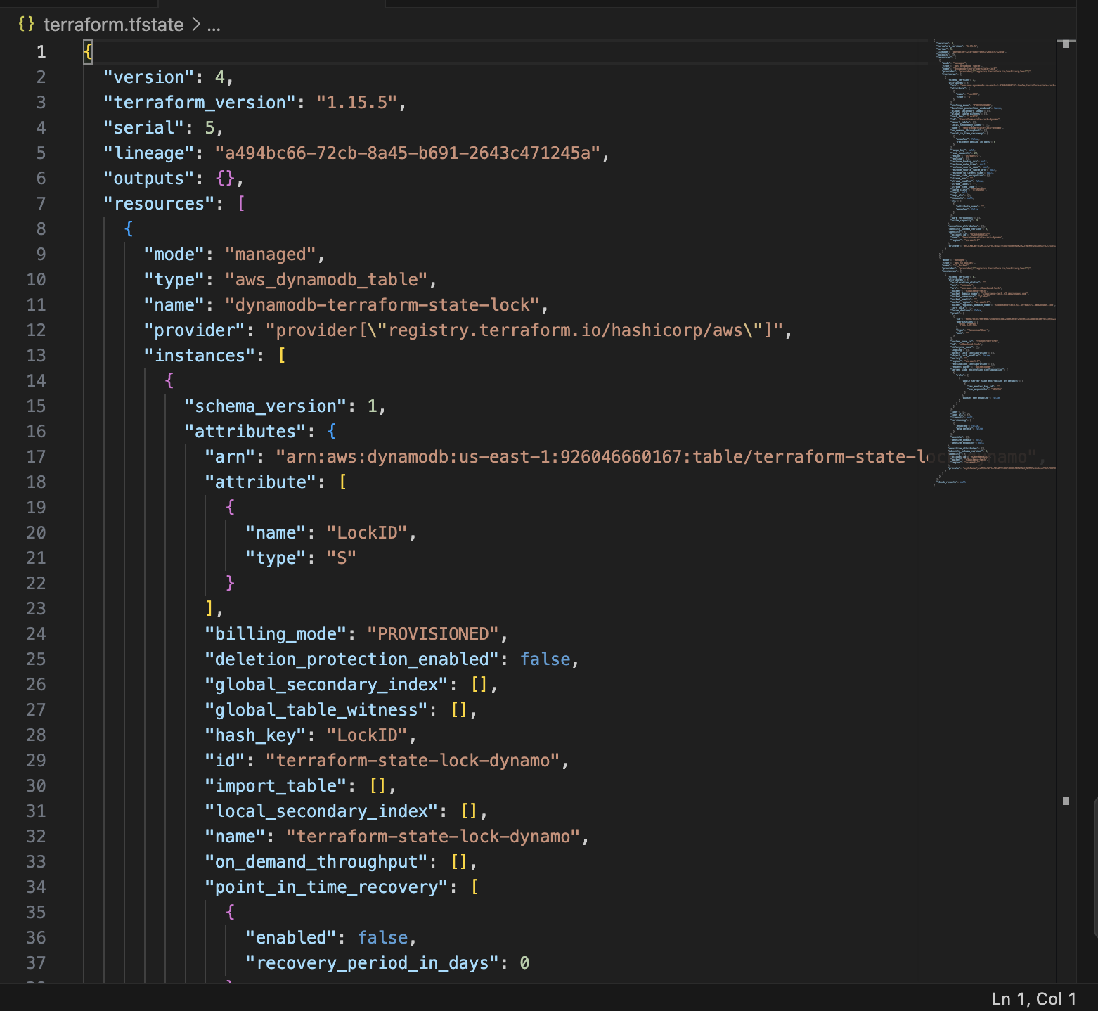
Now lets check in S3 the data should be stored.

The file has been moved to S3 - bucket which we have created
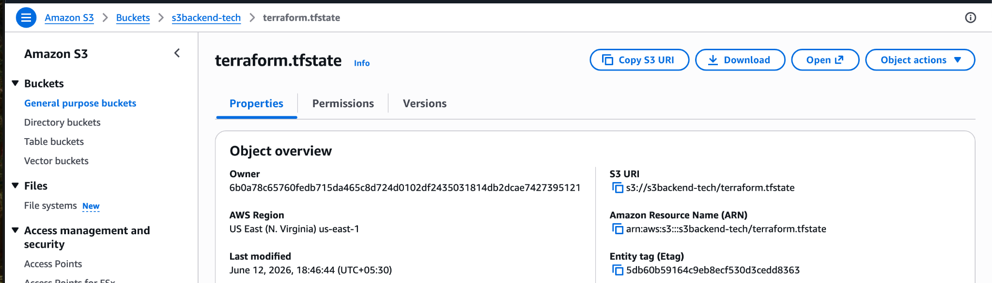

For checking the lock ID
DynamoDB→Tables→file created→explore items→scan→edit item
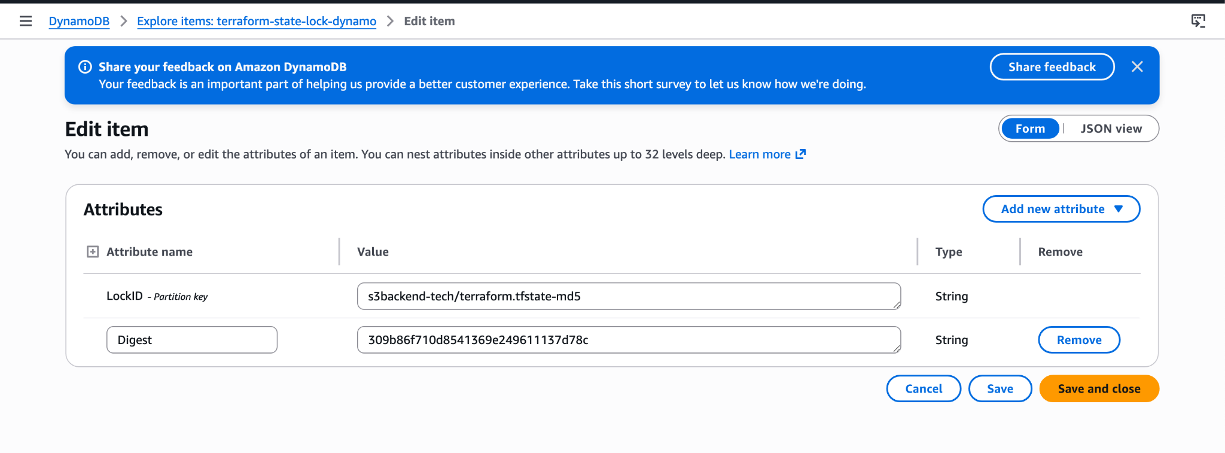

Lets add any resource block and see
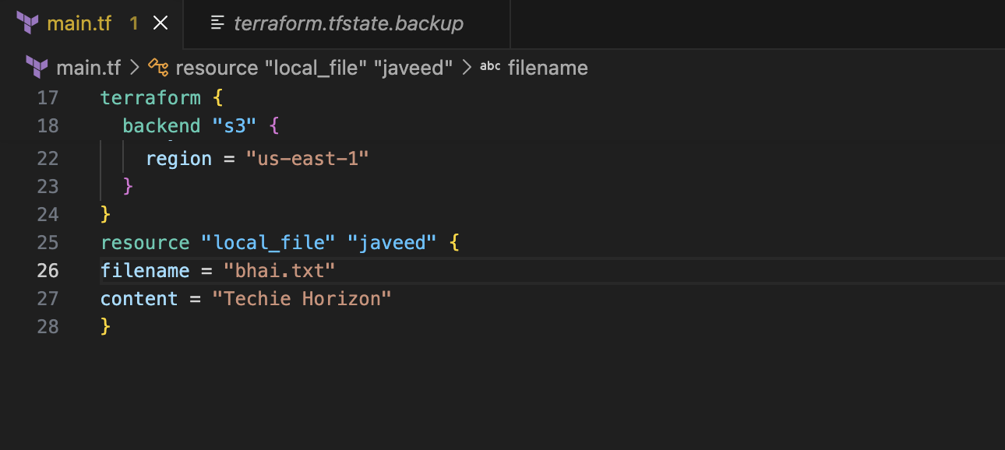
Its throwing an error as our statefile is locked
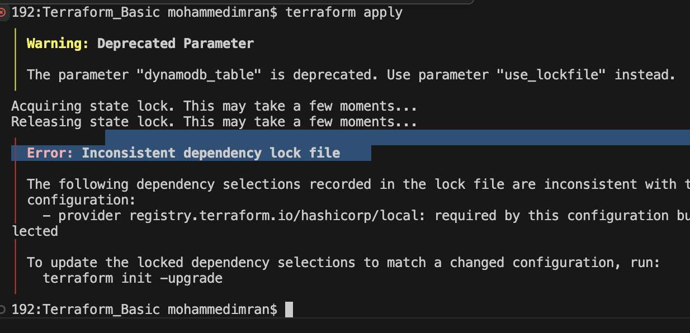

Lets use command terraform init so that it will release the lock and try again with terraform apply
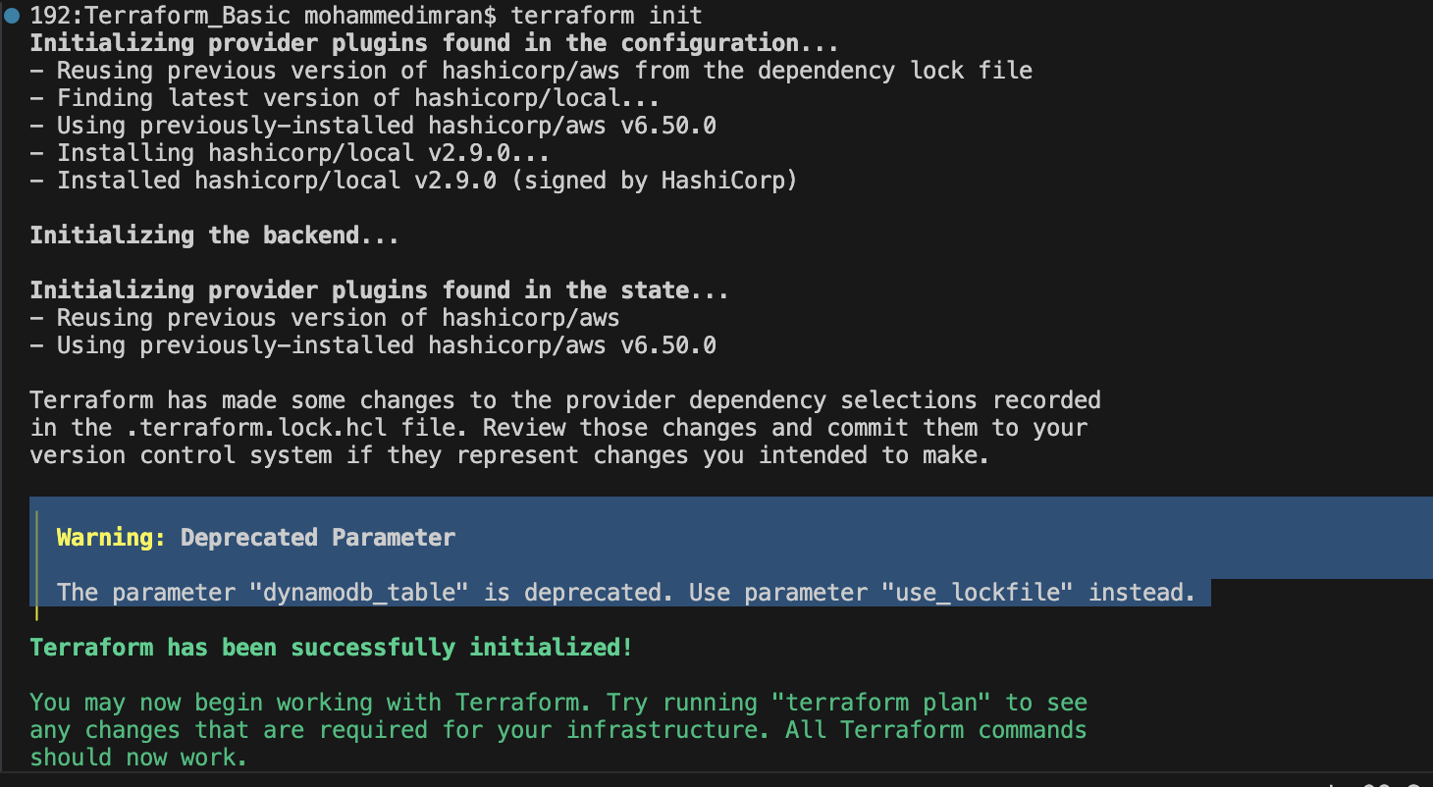
terraform apply
After doing terraform init, when we execute terraform apply it will acquire the lock from dynamo db and the resource block gets added
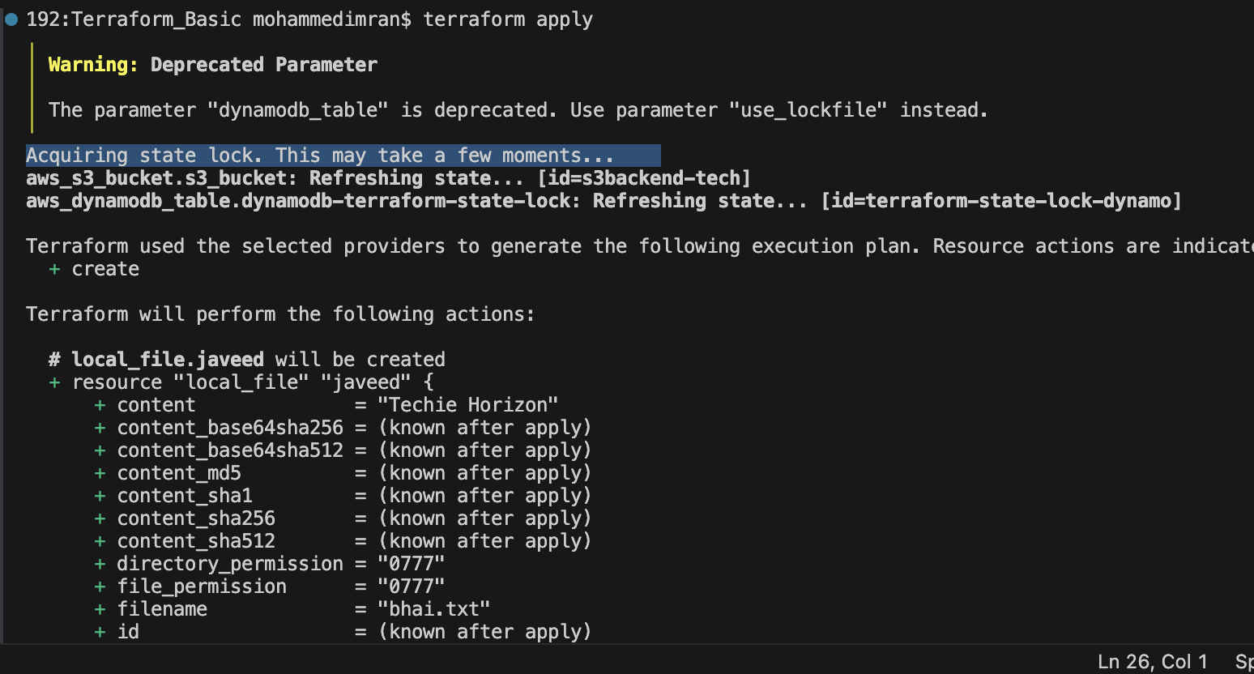

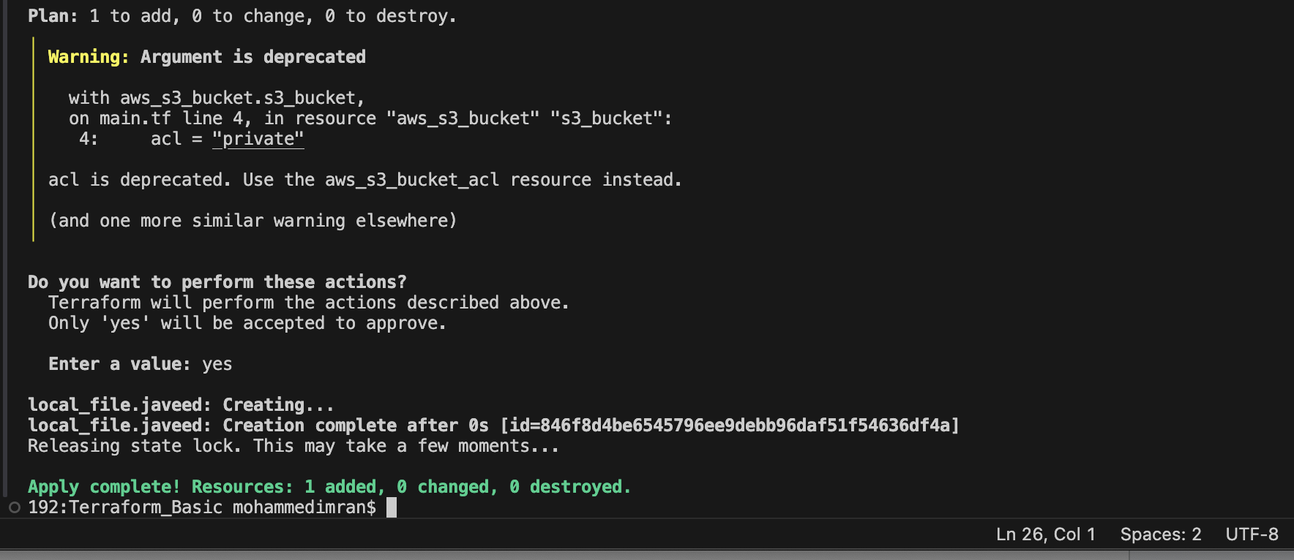

Lets create an Ec2 instance by using Provisioners

Lets create a main.tf file
resource "aws_instance" "nginx-server" {
ami = "ami-0b6d9d3d33ba97d99"
instance_type = "t3.small"
key_name = "jenkins"

associate_public_ip_address = "true"
subnet_id = "subnet-0d2e47f3b5fba65ea"

tags = {
NAME = "nginx-server"
}
}

Now terraform init
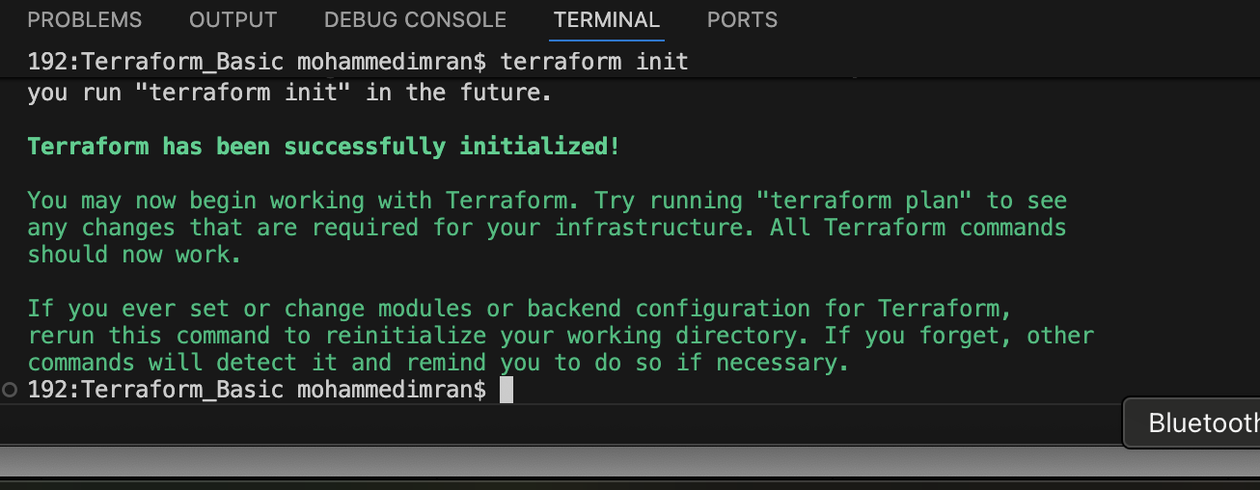
terraform plan ⇒ for DRY RUN
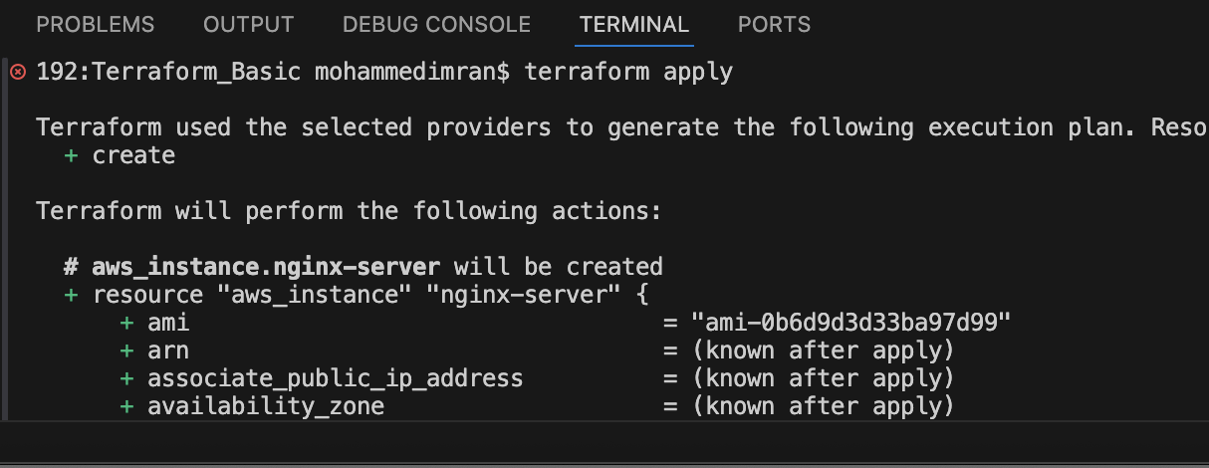
terraform apply
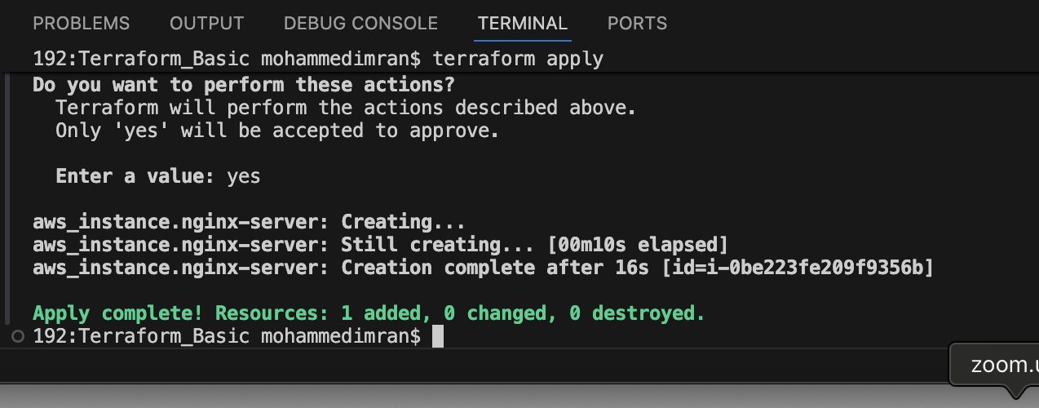
Lets see if ec2 instance has been created or not
Instance has been created

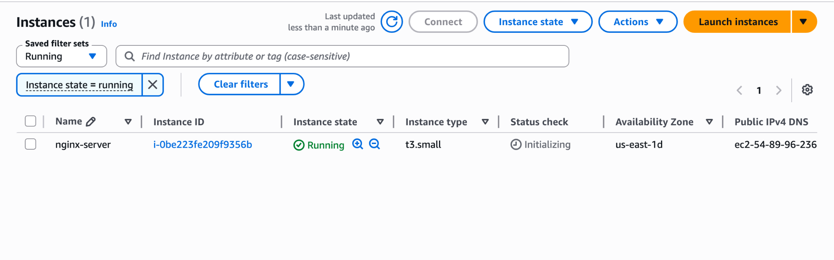
Lets add terraform provisioner
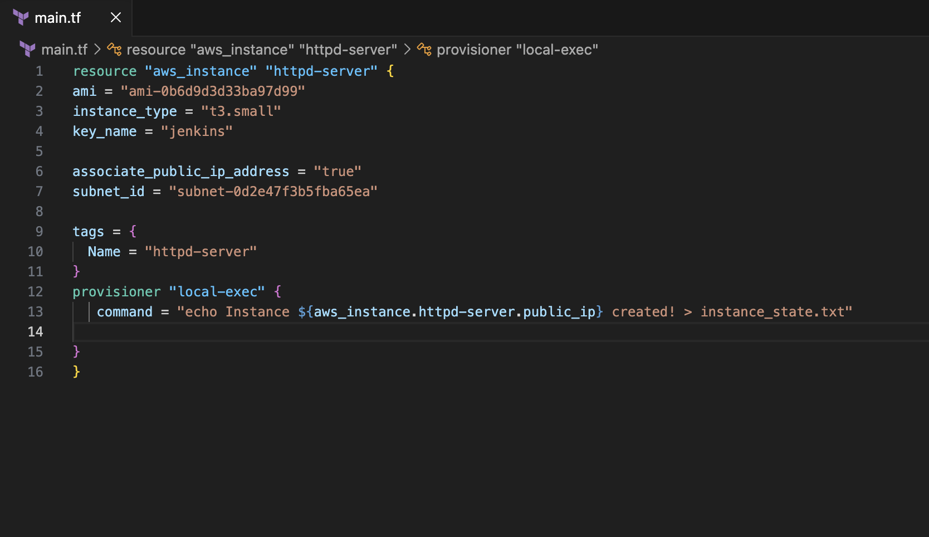
After adding provisioner in our script we need execute
terraform init
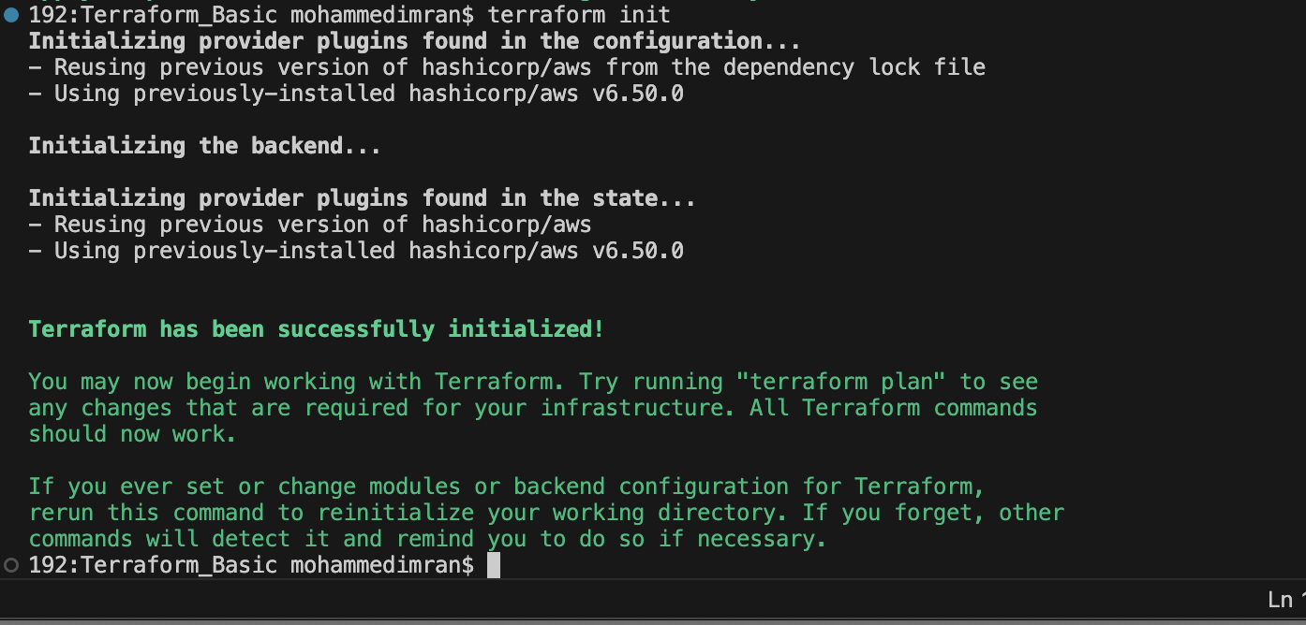
Now execute terraform apply and you should see instance_state.txt file must be created
So for this first we need to destroy the created infrastructure and then only provisioner will work
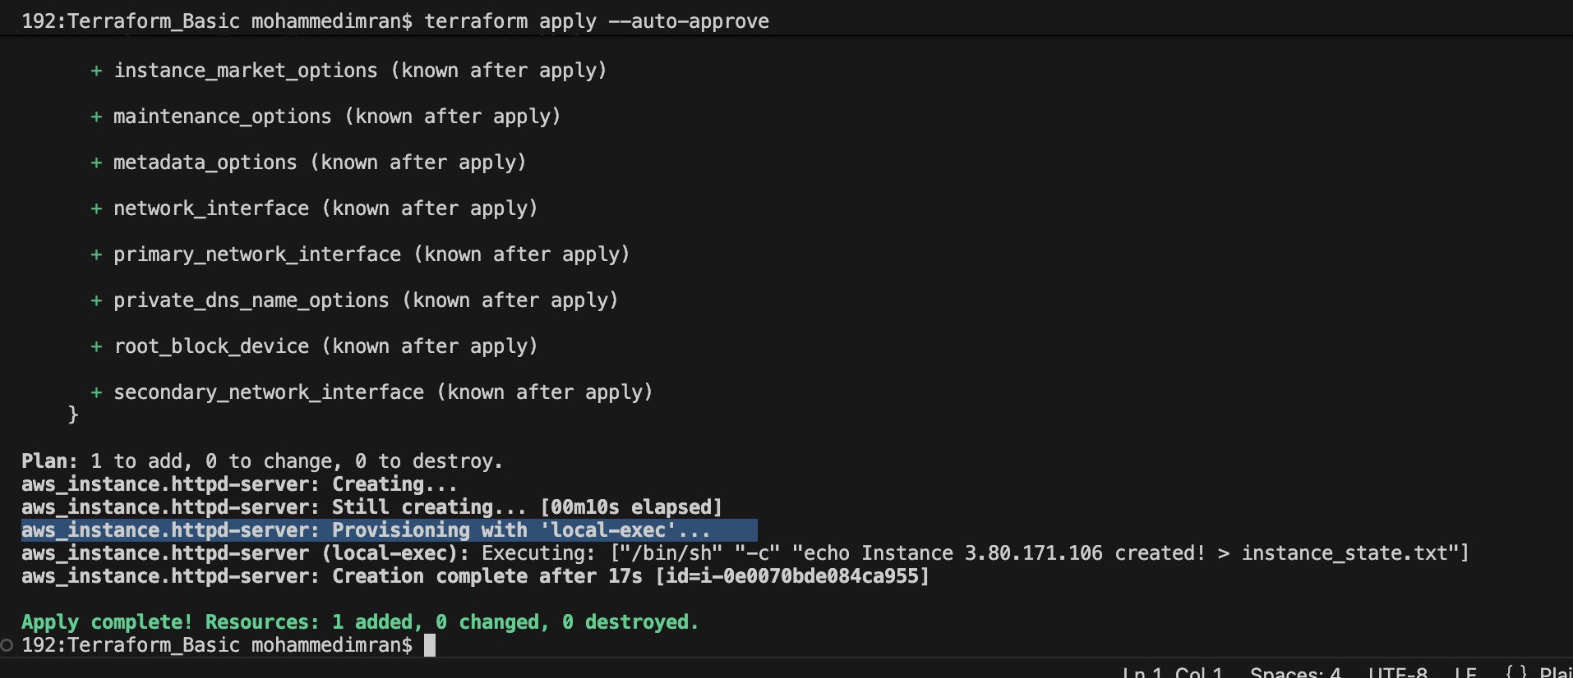
Instance_state.txt file has been created
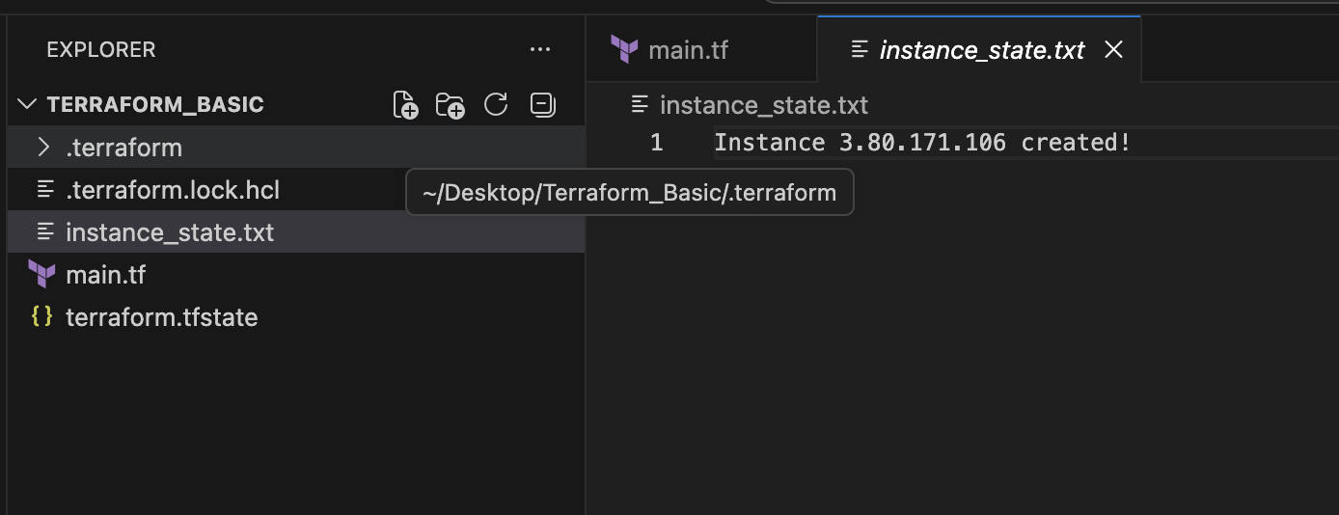

TAINTED AND UNTAINTED
A tainted resource is marked as unhealthy or potentially inconsistent. Terraform will destroy and recreate it during the next terraform apply. This can happen when:
- Resource creation partially fails.
- A provisioner fails after the resource is created.
- You manually mark it as tainted (terraform taint, now deprecated).
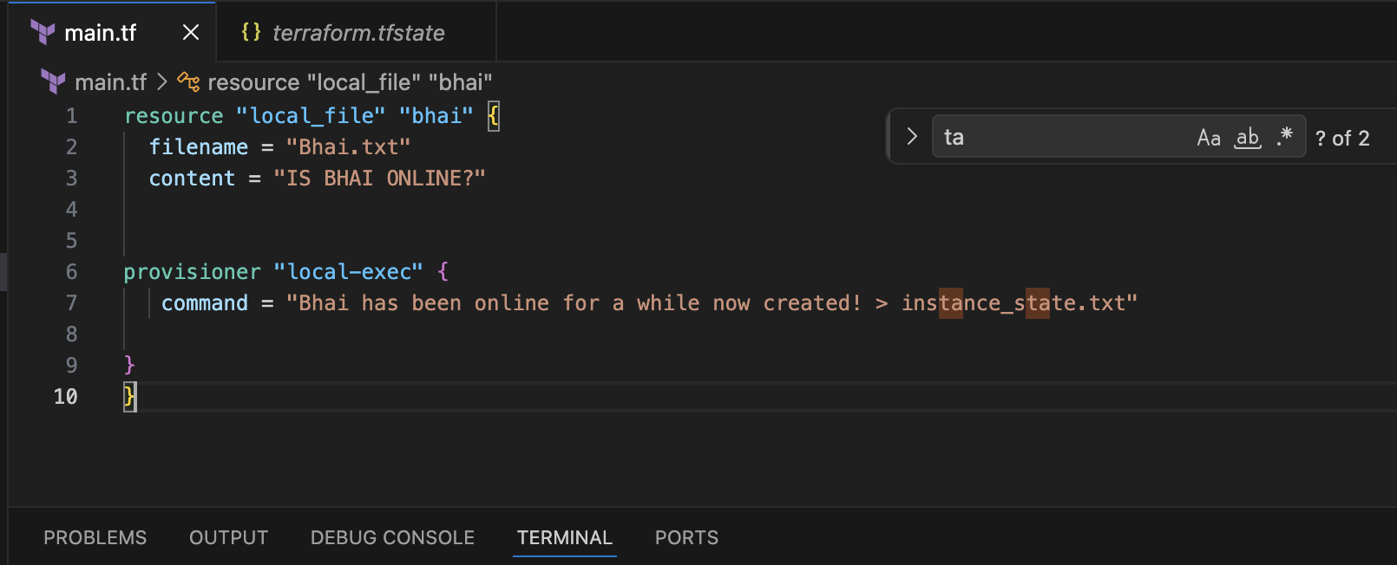
terraform apply ⇒ it will be throwing an error and when we check the terraform.tfstate file we
can see it has marked as “Tainted”
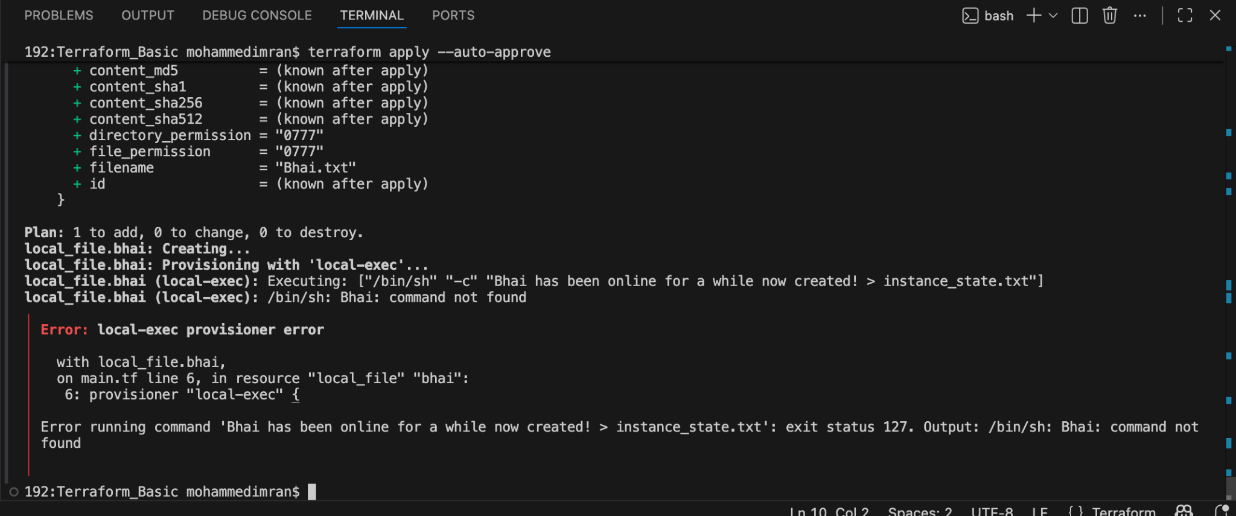
Lets check in terraform.tfstate
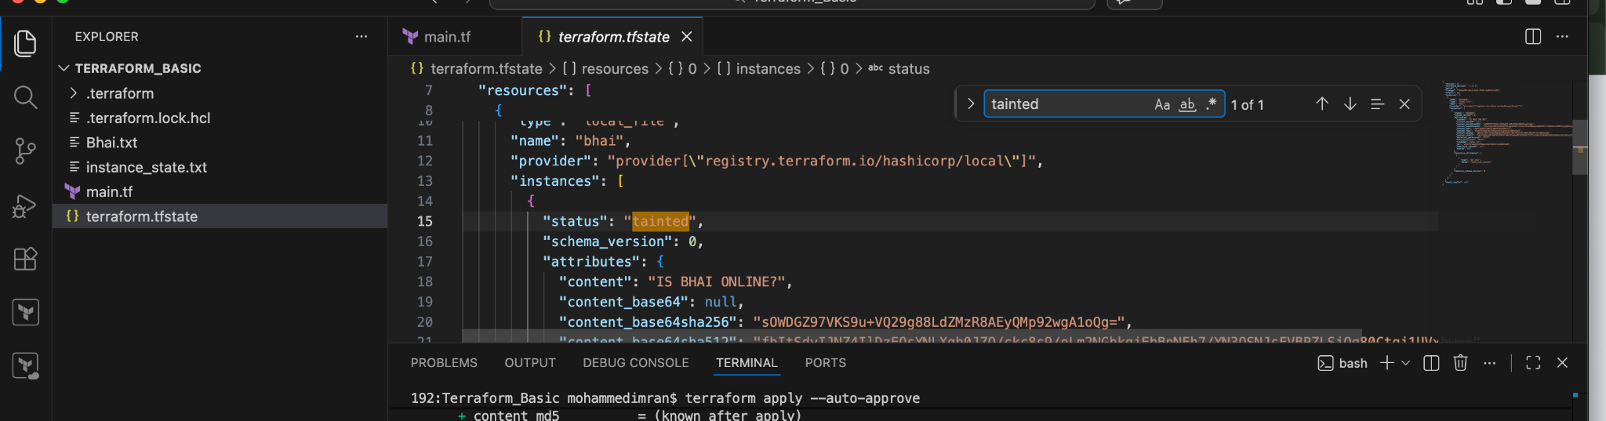
Lets untaint the file now
An untainted resource is considered healthy and managed normally by Terraform.
If Terraform marked a resource as tainted but you verify it's working correctly, you can remove the taint.

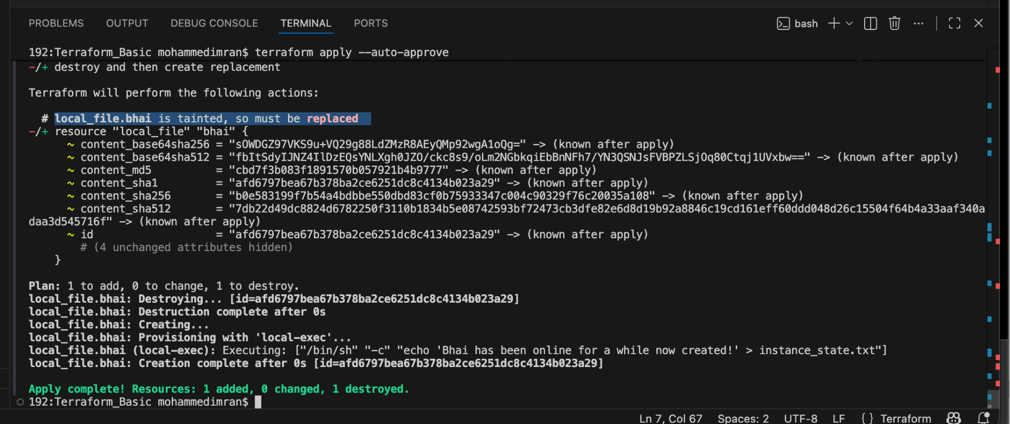
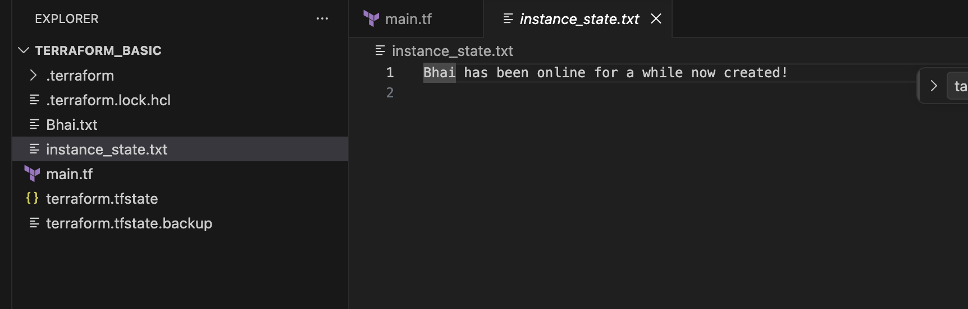

Debugging:
We will be getting basic logs when we use terraform plan
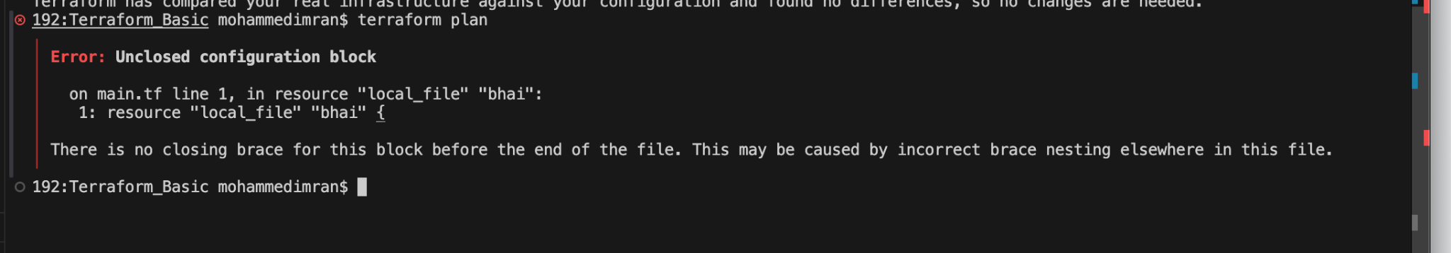
Now lets set the environmental variables and see
export TF_LOG_VALUE =”TRACE”
Now lets execute terraform apply
We can see all the logs
We have different types of logs
- INFO ⇒ Shows general execution details – like versions and providers
- WARNING ⇒ Shows warnings and errors
- ERROR ⇒ Shows only failures
- DEBUG ⇒ Shows provider interactions and detailed execution flow
- TRACE ⇒ Shows everything, including internal graph processing, state operations, and provider communications.

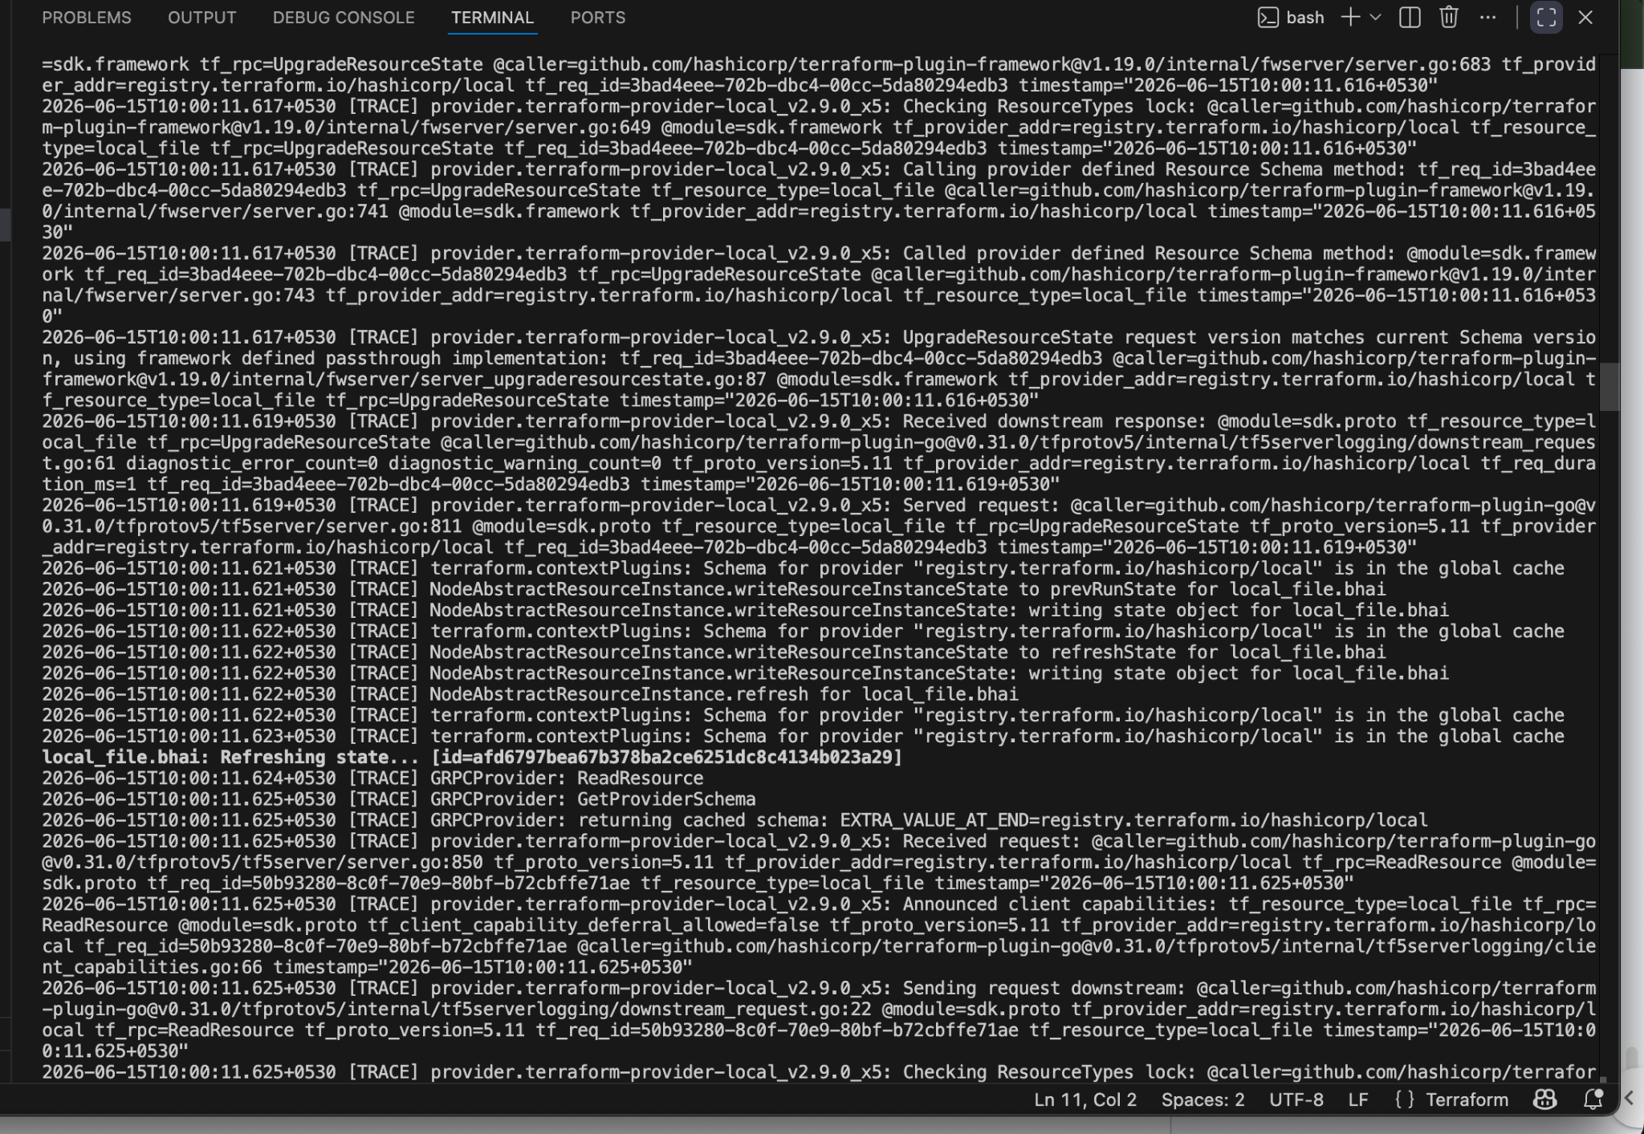
To return Terraform to normal behavior (no logging), remove the environment variables ⇒
unset TF_LOG
unset TF_LOG_PATH
Verify they're gone ⇒
echo $TF_LOG
echo $TF_LOG_PATH
If nothing is printed, logging is disabled.
Now Terraform will run normally.

3). Create one EC2 instance with httpd installed using a Terraform script.
Lets create a main.tf file

provider "aws" {
region = "us-east-1"
}

resource "aws_instance" "httpd_server" {

ami = "ami-0b6d9d3d33ba97d99"
instance_type = "t3.small"
key_name = "jenkins"

subnet_id = "subnet-0d2e47f3b5fba65ea"
associate_public_ip_address = true

user_data = <<-EOF
#!/bin/bash
sudo apt-get update -y
sudo apt-get install apache2 -y
sudo systemctl enable apache2
sudo systemctl start apache2
echo "<h1>Welcome to Apache2, Installed By Terraform --- Executed BY JAVEED</h1>" | sudo tee /var/www/html/index.html
EOF

tags = {
Name = "apache-server"
}

provisioner "local-exec" {
command = "echo Instance ${self.public_ip} created! > instance_state.txt"
}
}
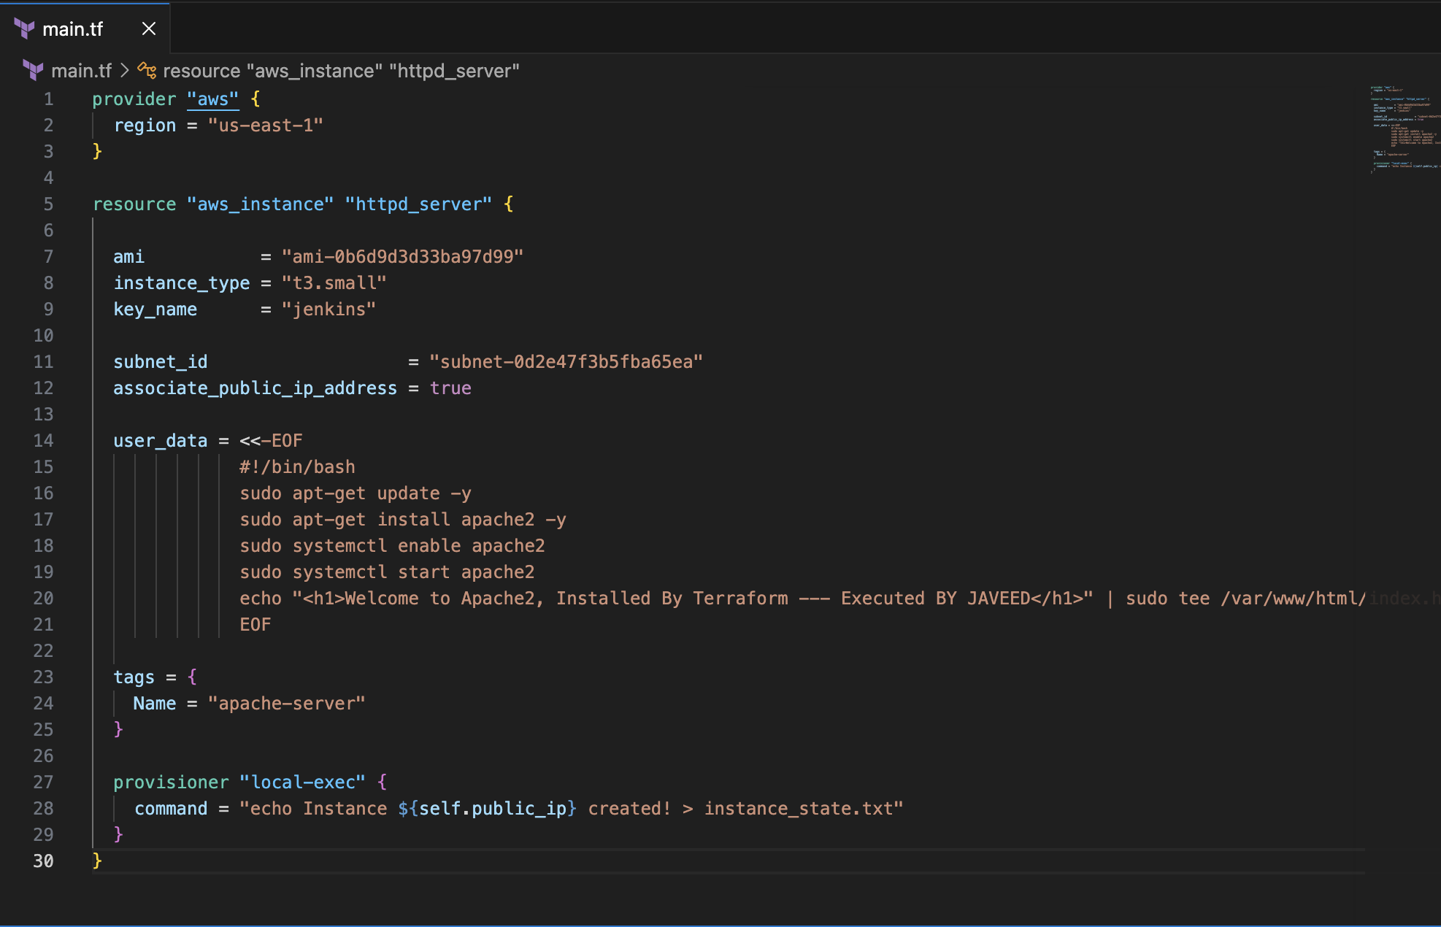
Apply terraform init
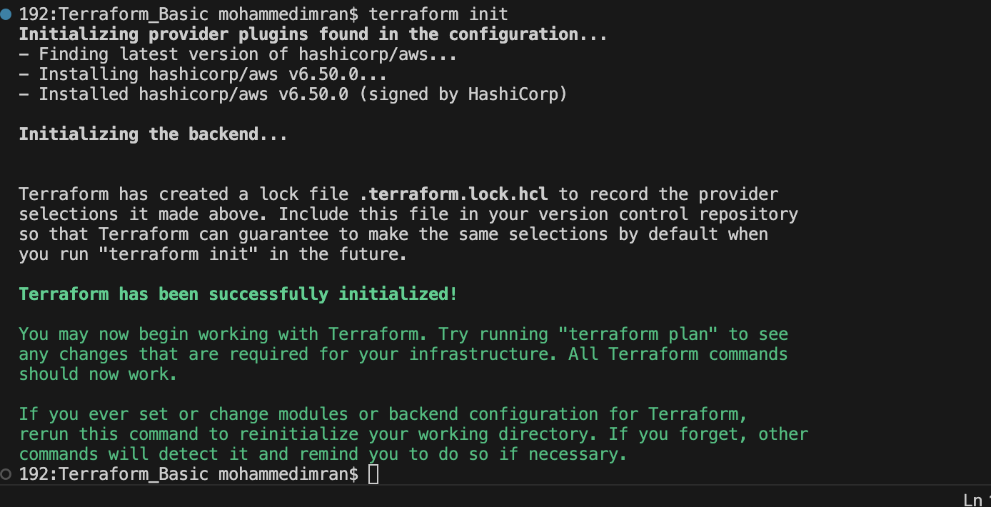
terrafom plan
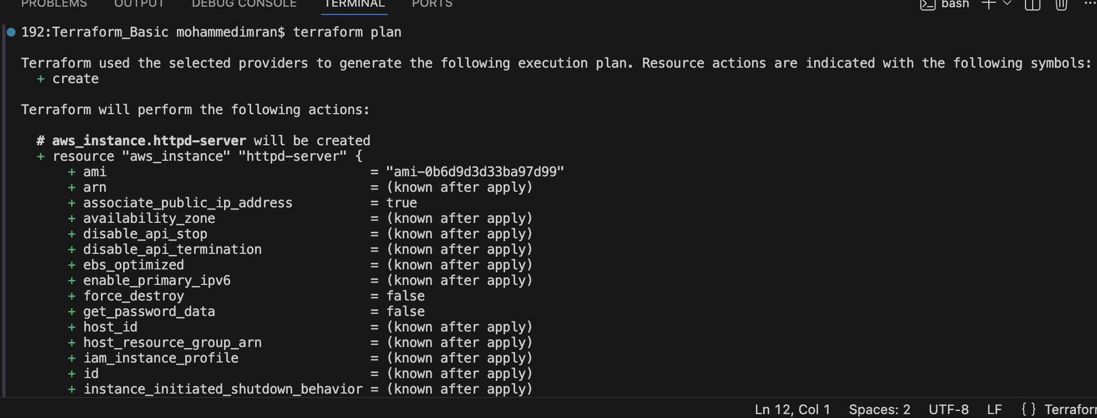
terraform validate
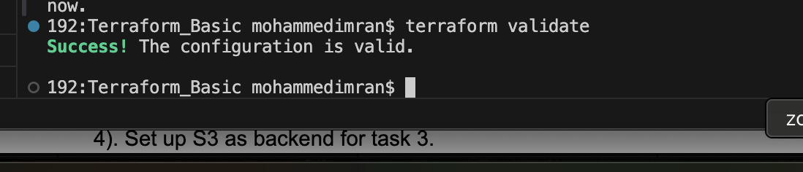
terraform fmt
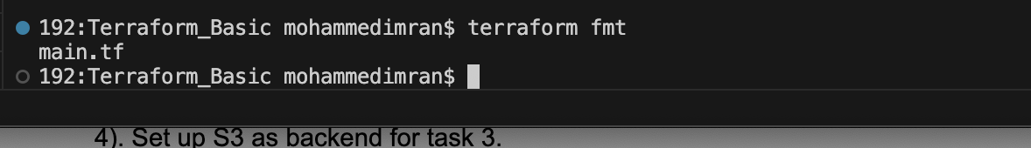
terraform apply
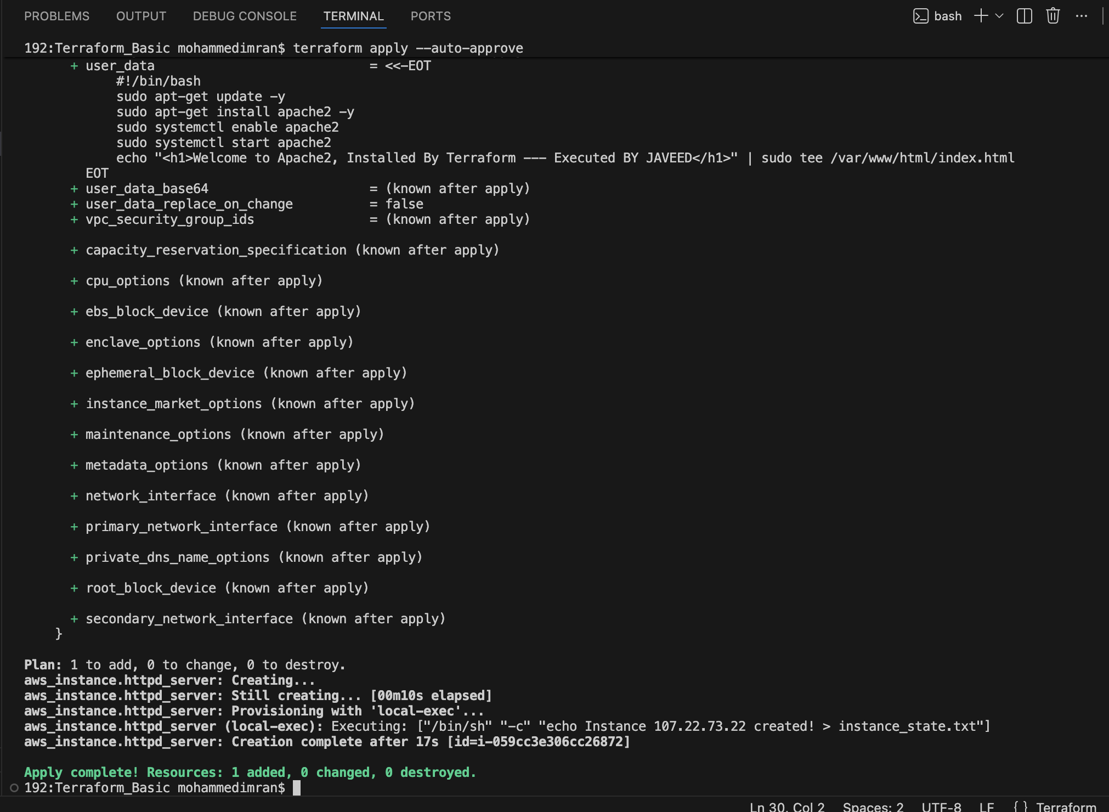
Now lets check in ec2 instance if the instance has been created and apche2 has been installed or not
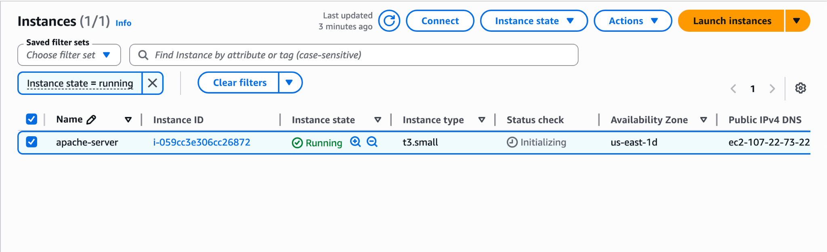
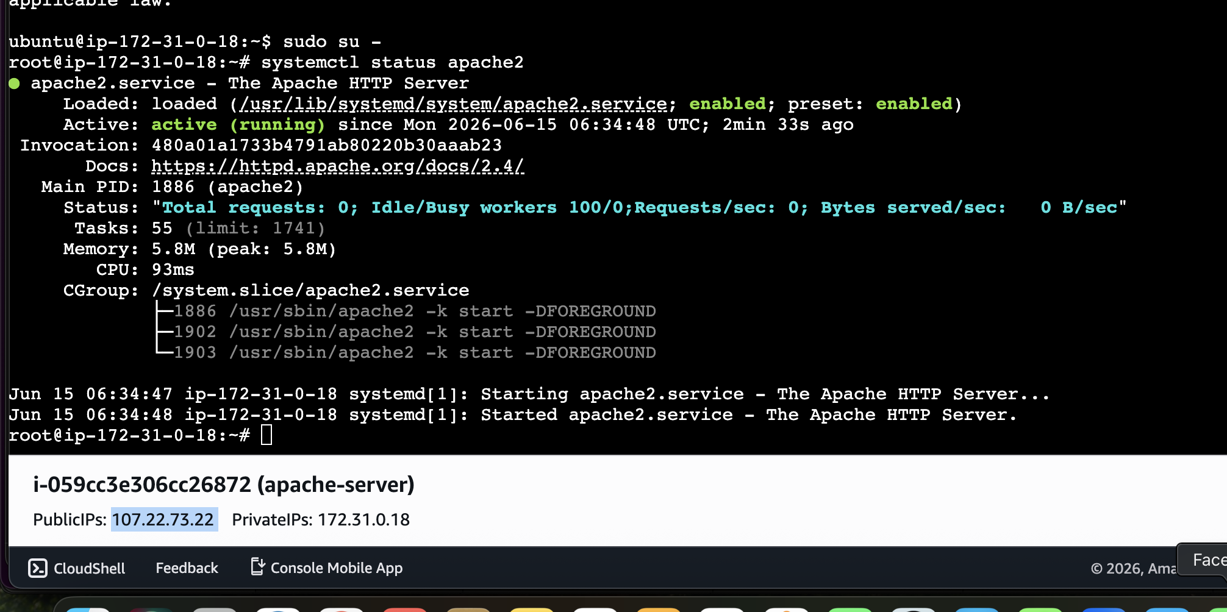
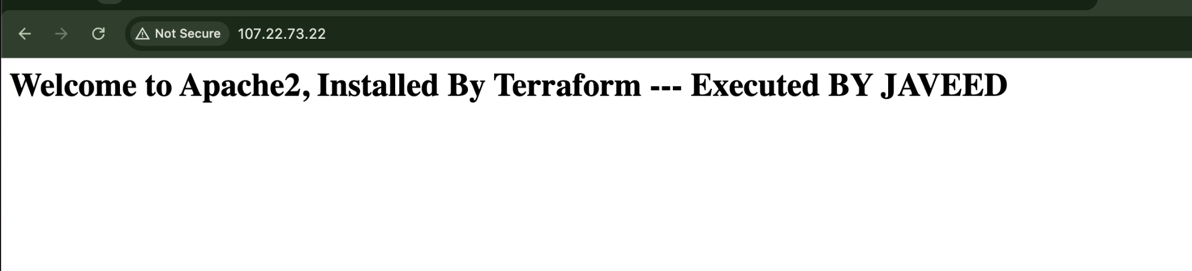

4). Set up S3 as backend for task 3.
So lets create an s3 bucker first

resource "aws_s3_bucket" "s3_bucket" {

bucket = "s3backend-tech"
acl = "private"
}
The above script should be added in our main.tf file
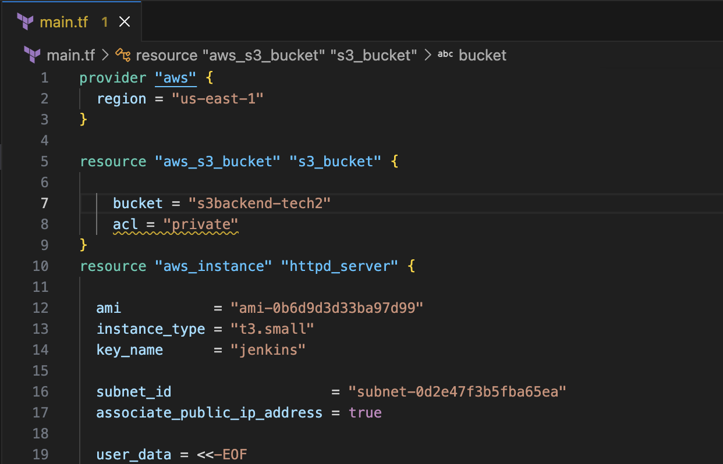
terraform apply
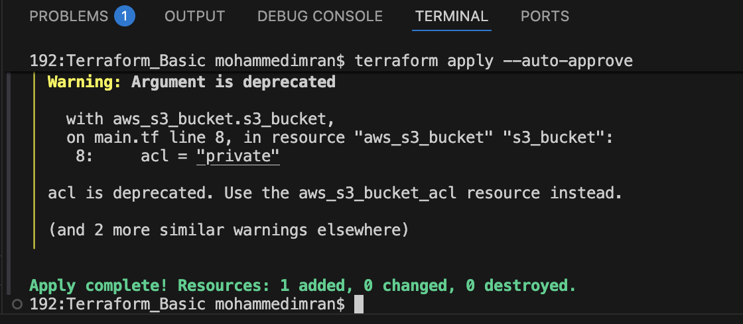

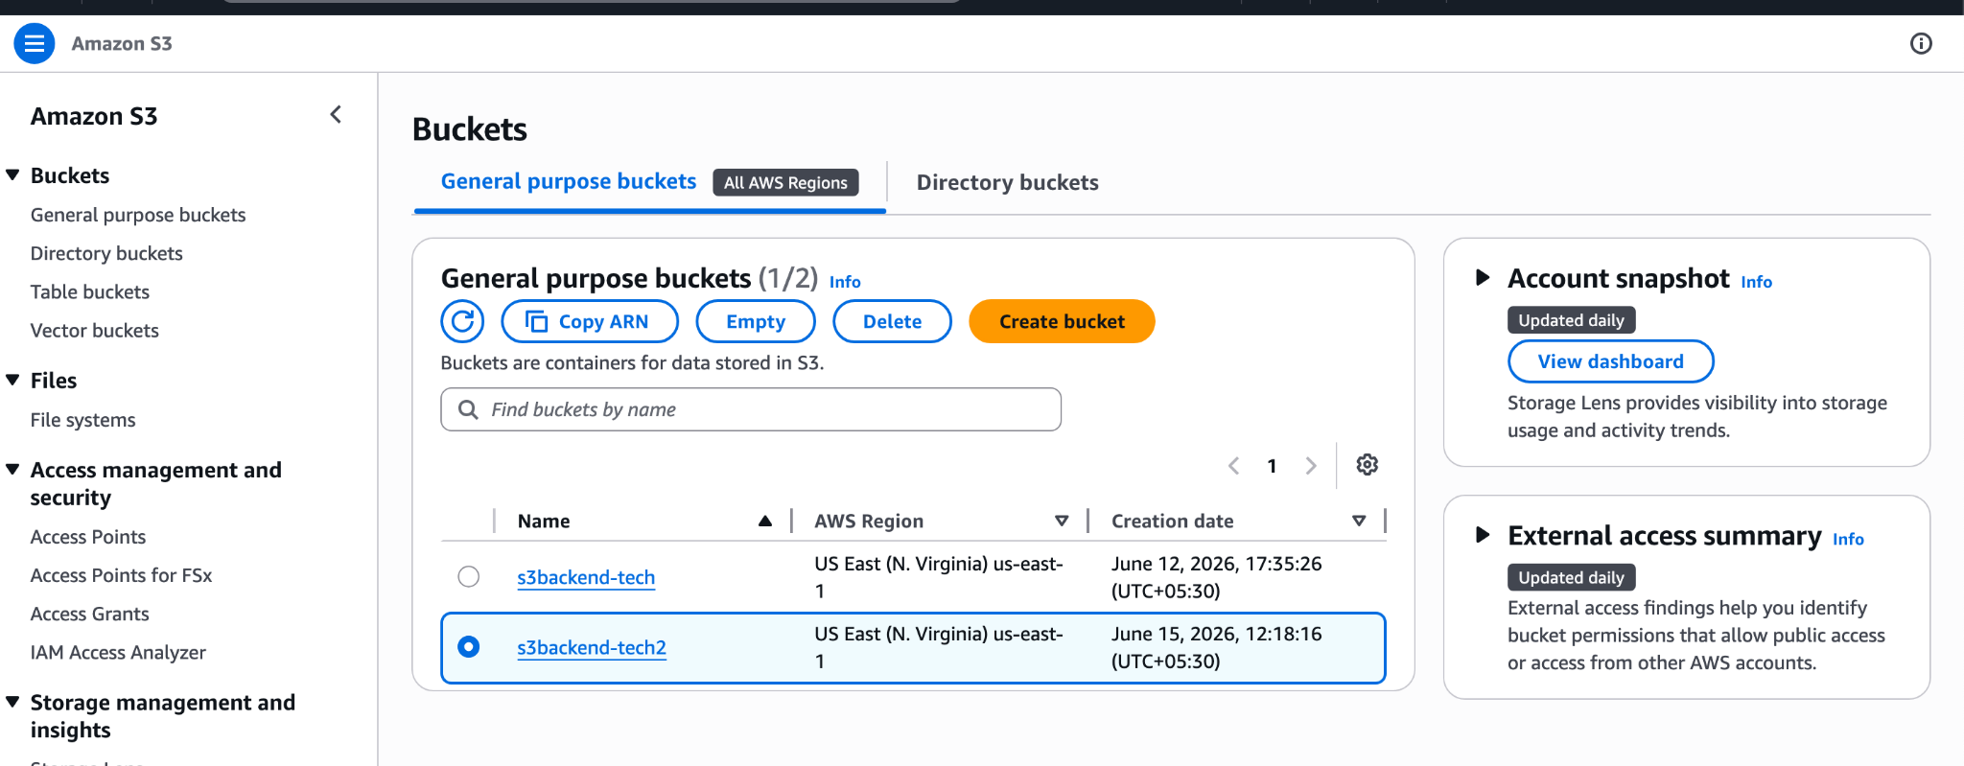As our question says about backend lets write a script
terraform {
backend "s3" {
bucket = "s3backend-tech"
key = "terraform.tfstate"
region = "us-east-1"
}
}
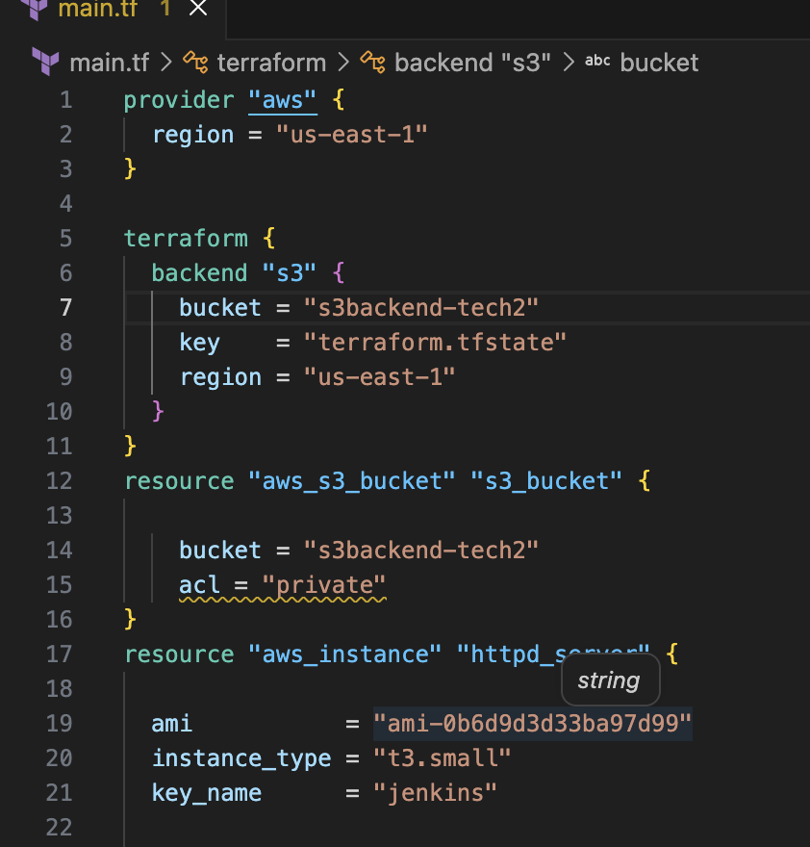
As we are using backend we need to intialize our terraform
terraform init
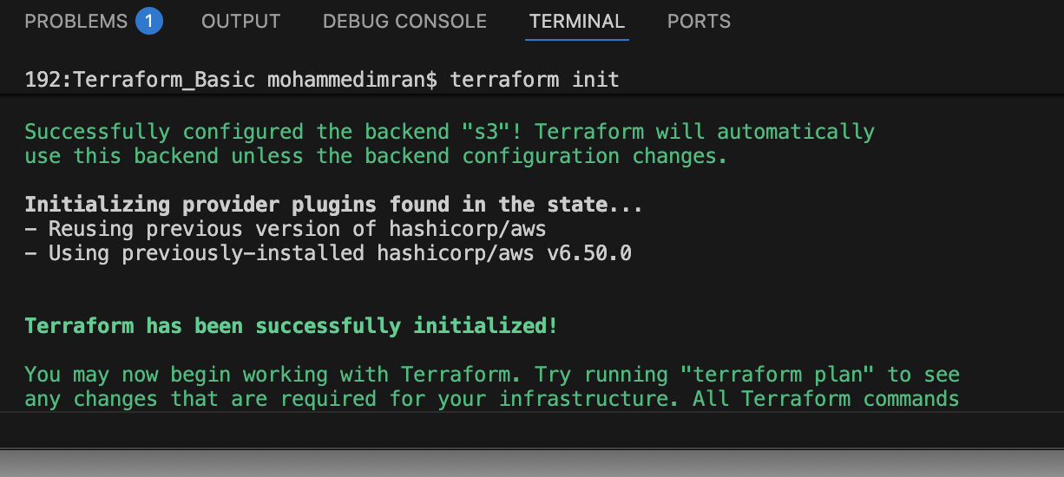
Lets do terraform apply and see if the statefile has been moved to s3 bucket or not
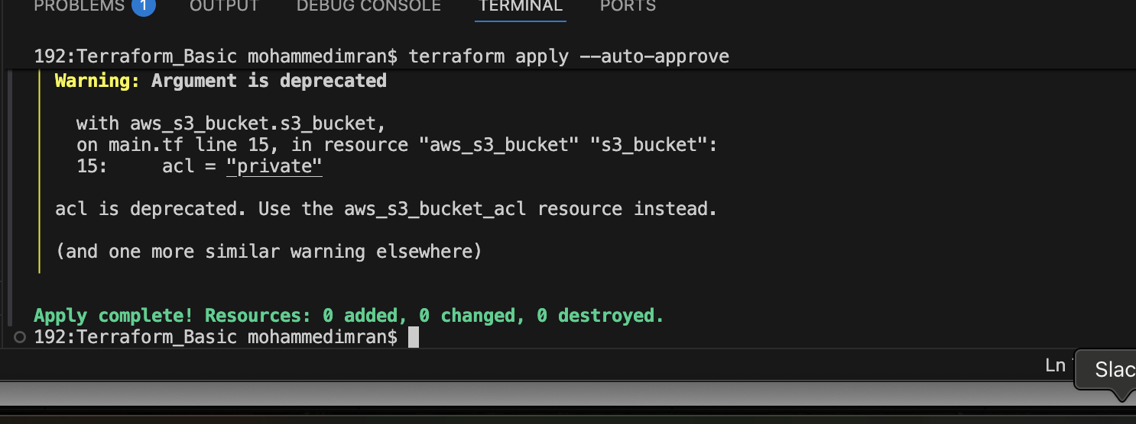
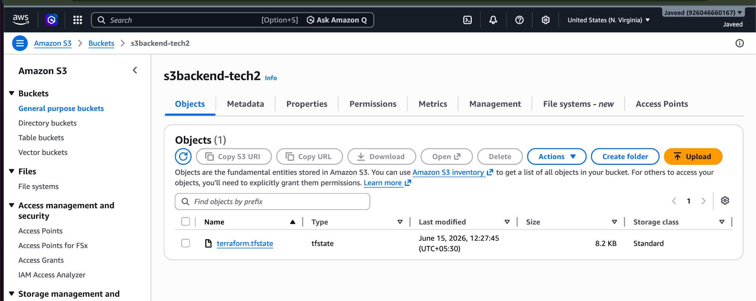

5). Set up DynamoDB locking for task 3.
Lets create a dynamo db table first
resource "aws_dynamodb_table" "dynamodb-terraform-state-lock" {
name = "terraform-state-lock-dynamo2"
hash_key = "LockID"
read_capacity = 20
write_capacity = 20

attribute {
name = "LockID"
type = "S"
}
}
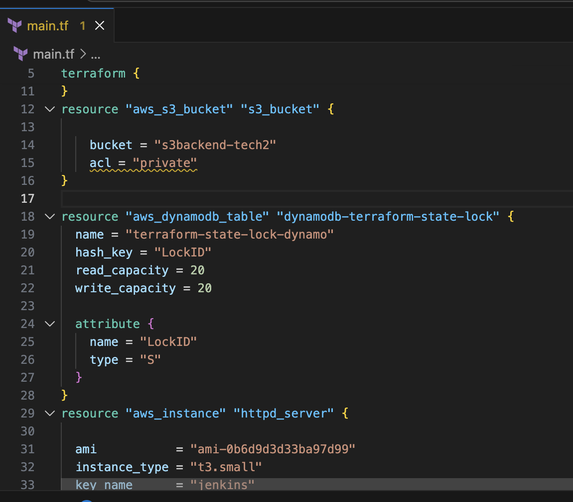
terraform apply
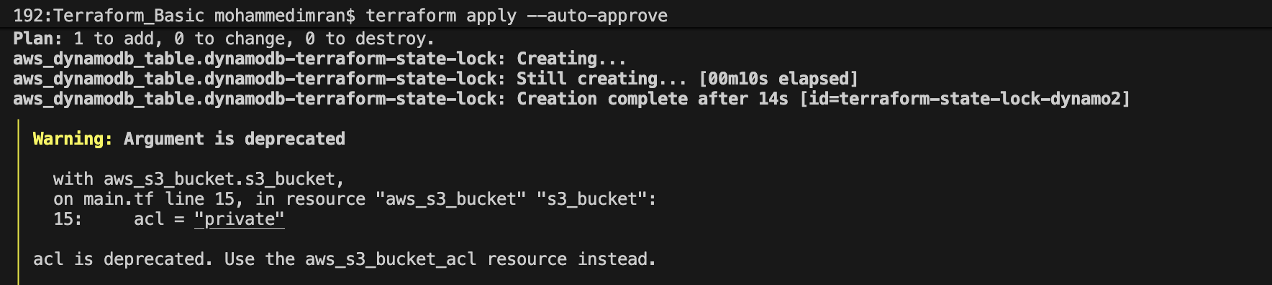
Table has been created
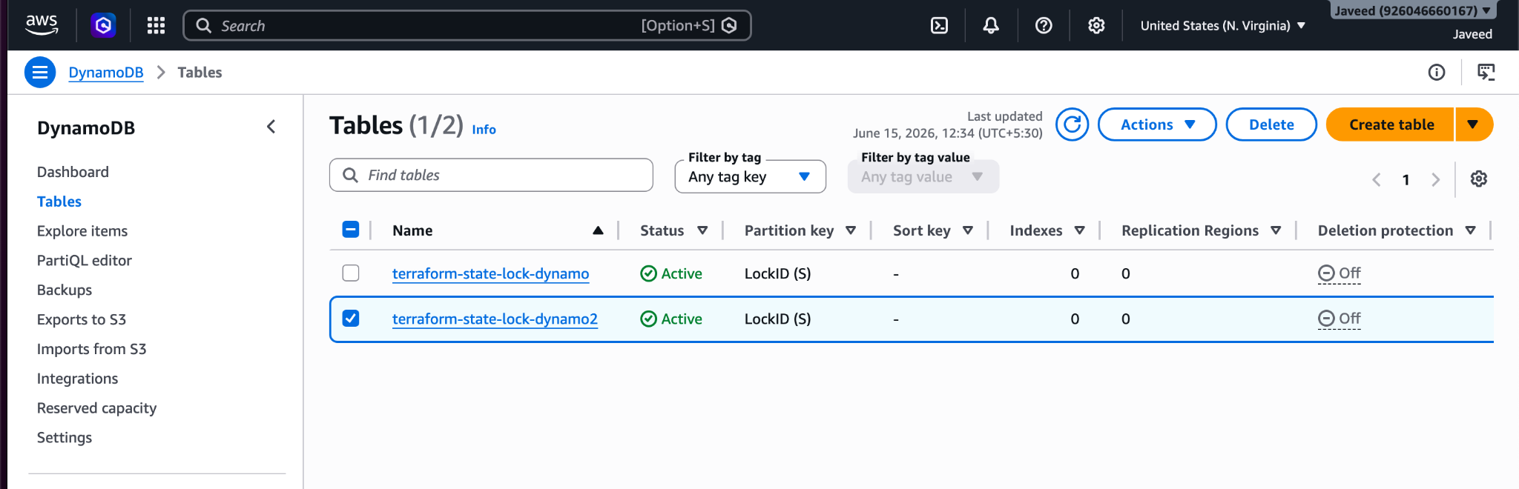
Now lets setup the locking in the backend to secure our statefile

So for this in our terraform block we need to only add our dynamo db table name
dynamodb_table = "terraform-state-lock-dynamo2"

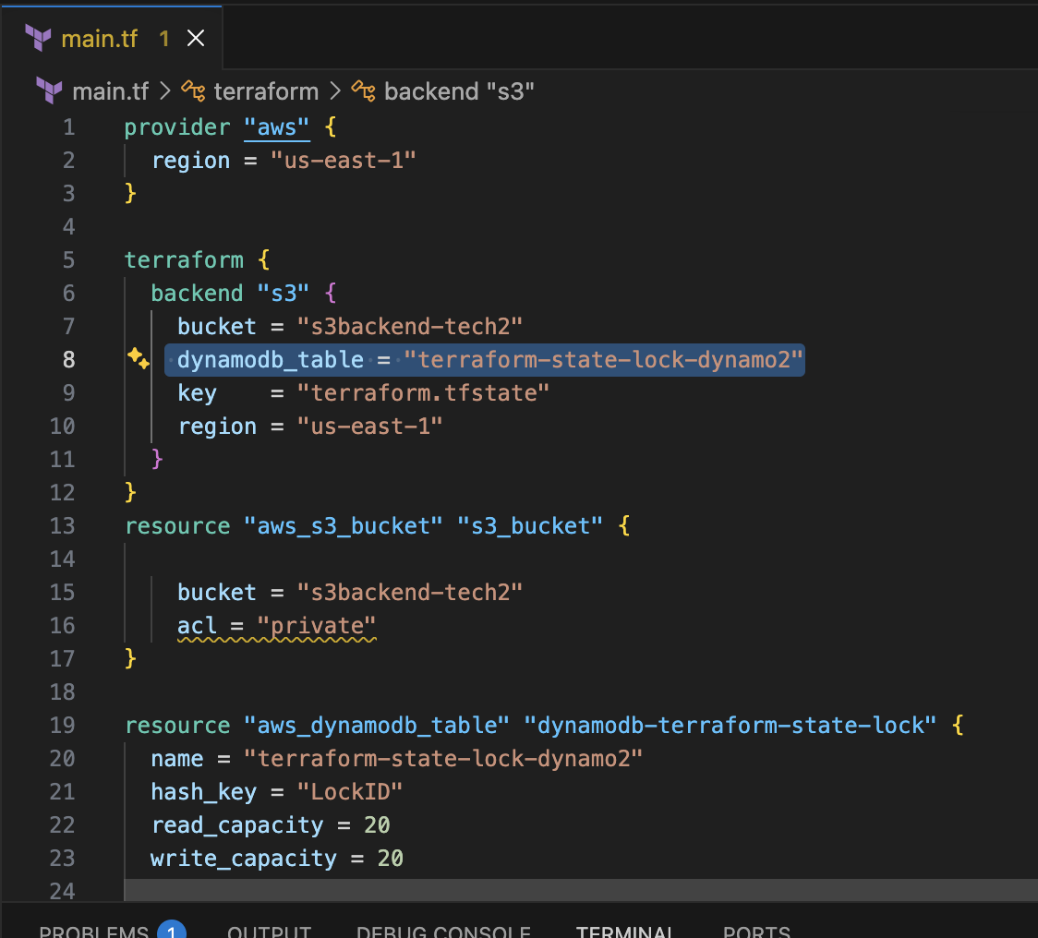
Lets perform terraforminit and terraform apply
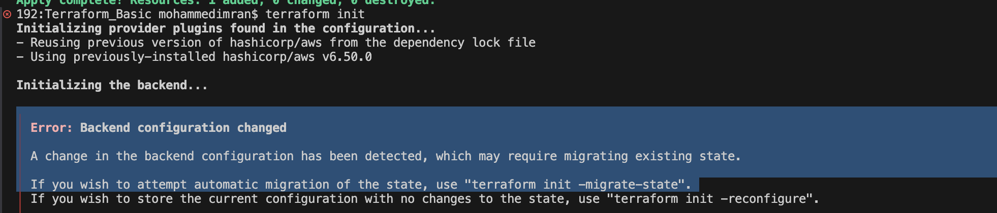
It throws an error
As the backend configuration has been changed.
So lets execute terraform init -reconfigure⇒ When we modify the backend block, Terraform detects a backend configuration change, so we must reinitialize.
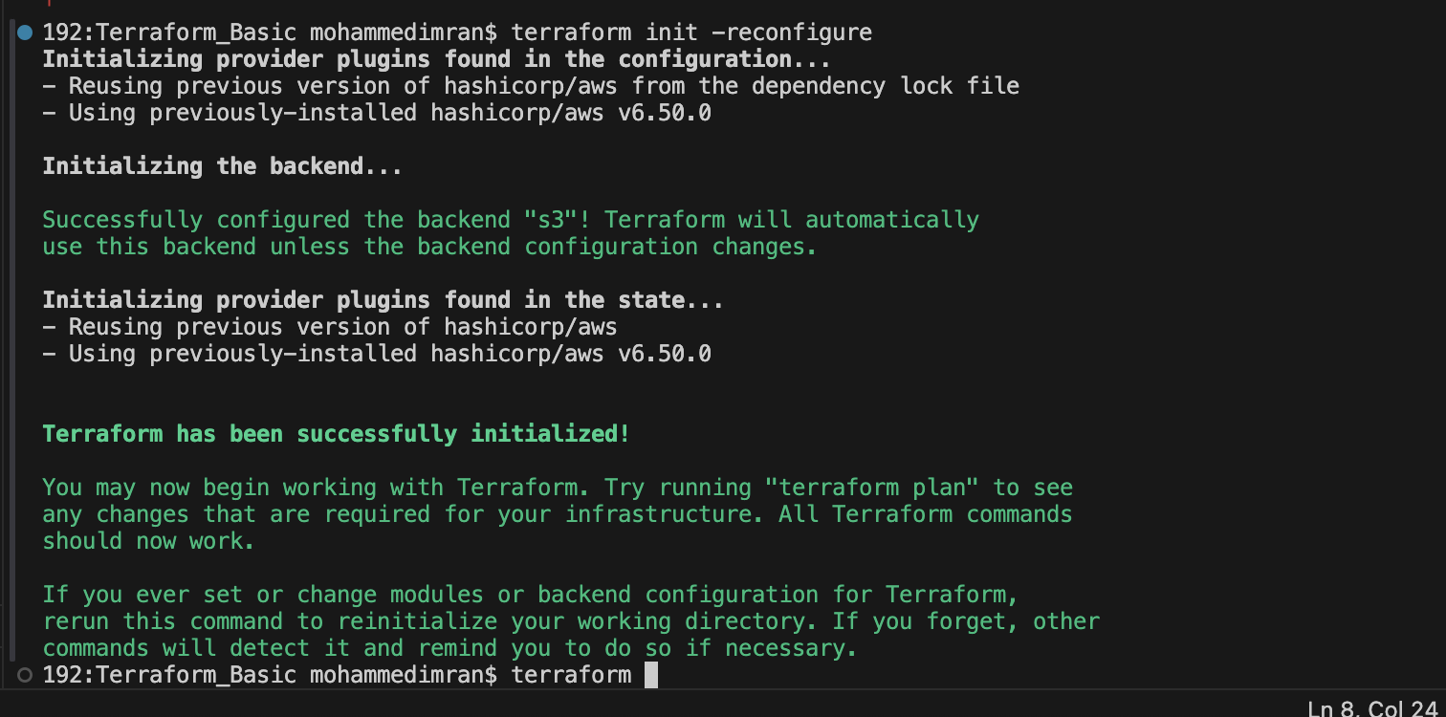
So now our statefile should be successful locked
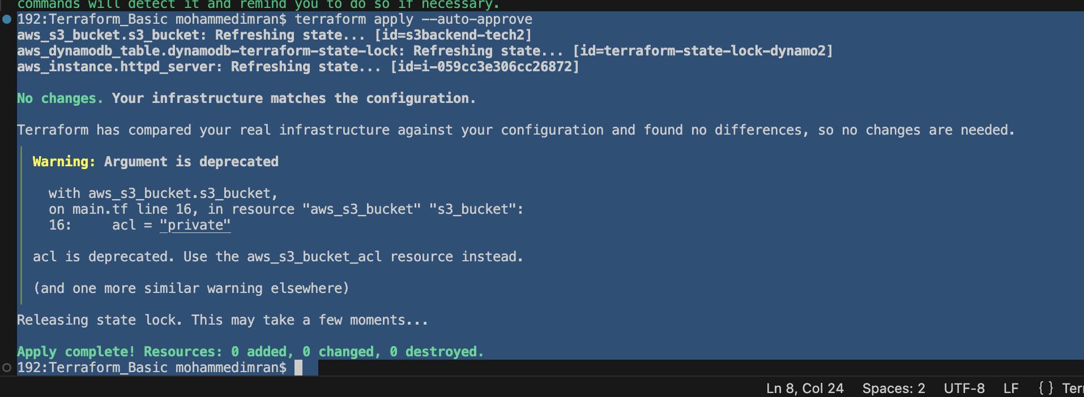
Lets confirm
